The 21st century skills teachers should have
7:31 PM 21st century teaching skills, educational technology 4 comments Med
In one of my previous post entitled what every teacher should know about google. reference was made to the notions of the 21st century learner and how these learners depend wholly on media and social networking to live in this fast paced world. In today’s post i will present two short videos that will hopefully change what some think about teaching. The following videos are among the top educative videos online .
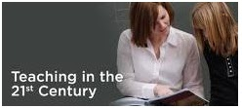
With the advance of technological innovations into our lives , education has been radically transformed and teachers who do not use social media and educational technology in thier teaching no longer fit in the new system.That’s why every educator and teacher should reconsider certain values and principles . watch this first one minute 40 seconds video to see the negative side that every teacher must not have
Negative version of when i become a teacher
So if you want to fit in the system and develop professionally then this is how to do it . watch this short video to learn more
positive version of when i become a teacher
In order to adequately prepare today's students for their future, teachers must effectively
- share and model the use of current internet tools
- participate in professional networks
- assist students as they build their learning networks
- provide sufficient learning opportunities for students to become digitally literate
- inspire every child to be quality digital global citizens.
The 21st century teachers are characterized by certain holistic and student centered features , some of them are summarized below . Gratitude and thanks goes back to Andrew Churches who has provided this diagram .
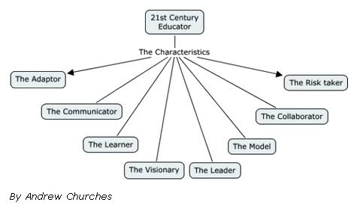
The risk taker :
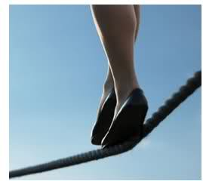
teachers should not wait for others to take the initiative , they have to do it first and take risks . Show your students that everything can be learnt through risk and initiative taking and sometimes surrender yourself to the students’ knowledge . The students will love you and trust you and this trust is the key to better learning .
The Collaborator :
The central theme in your work should always be collaboration . Incorporate the collaborative tools web2.0 offers , they are free and highly effective. Ning ,Bebo, Myspace, Secondlife, Msn, blogger and wikispaces. leverage these tools and captivate your students .
The model :
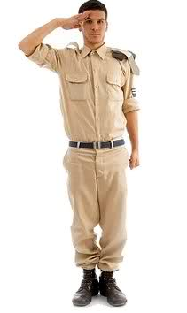
teachers should not only teach knowledge but they should teach values as well . Students are very much influenced by their teachers' behaviors therefore the 21st century teachers need to model several characteristics such as :
- Reflective thinking and practice
- Tolerance
- coexistence
- affection, love , tenderness
- love of technology and digital information
- Global awareness
The leader :
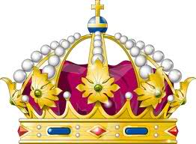
To understand what is meant by leader, Thousand and Villas paper, Managing complex change towards inclusive schooling summaries this brilliantly. Vision, incentives and action plan are all elements of leadership:
The visionary :
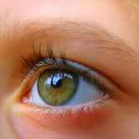
Teachers must be imaginative . They need to foresee the potential in the emerging web2.0 tools and technologies, look into other areas of the curricula and across disciplines, make links that enhance and value learning in other fields to leverage this knowledge and reinforce their teaching and the learning of their students .
The learner :
Learning is a continuous process , a life long commitment to knowledge , teachers should always seek knowledge everywhere using technology . The world is dynamic and the horizons and landscapes are changing so do the teachers’ needs and skills Unless we keep up with the change through learning and adapting we will be outdated teachers.
The communicator :
the 21st century teacher should be fluent in the use of communication and information technologies ,know how to facilitate them, stimulate and control them, moderate and manage them.
The adaptor :
Different as they are the modes of learning , teachers should always make their teaching styles adaptive to :
- the new curriculum requirements
- the emerging web2.0 technologies
- the various age groups and abilities
- the new dynamic teaching experiences.
These are just some of the new characteristics of 21st century teacher , if you have any additions to the list please write it below .
To conclude , i have selected for you this great video provided by PearsonFdtn let’s watch what these leading educational thinkers say about the 21st century skills teachers need to have . Enjoy watching .
Teacher Education and 21st century skills

You might also like:
- What every educator should know about google
- Google bookmarks in Education
- Google Reader in Education
- Google docs in education
- Rss feed in education
- Google Buzz in Education
- igoogle in The Classroom

