The 21st century pedagogy teachers should be aware of
4:11 PM 21st century teaching skills, educational technology 7 comments Med
Interpersonal learning , personalized learning, second life learning , 3d learning, collaborative learning and virtual learning , these are just some of the few buzz words you would be hearing so often in today’s educational literature. Things have changed , old methods and pedagogies are no longer relevant. The teacher-controlled learning where deconstructed and reconstructed information is presented in a highly formal and standardized classroom settings becomes very obsolete. The urgent questions we should , as educators , ask ourselves are : what is it that made this huge transformation in learning ? and Do we need a new pedagogy to better enhance learning ?
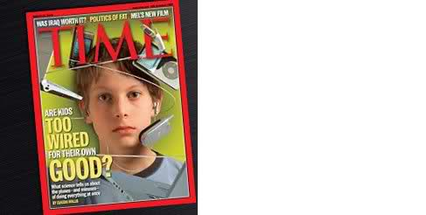
Globalization, the information age , and the knowledge era are the key terms you need to ponder about . Advancements in technology and particularly social networking technologies are changing the whole educational framework . Users now can have access to information whenever and wherever . Blogs , wikis, socializing sites, podcasts, networks are more and more democratizing knowledge and creating huge impacts on the process of schooling.
It is evident now that the fact that the 20th and 21st century learning is different in terms of skills and perceptions, the need for a new educational model , a serious rethinking of the nature of schooling , its goals, pedagogies, curriculum , structures, and assumptions is persistently urgent. In brief, We need a new pedagogy with specific features that would meet the new century expectations.
If you want to learn more about teacher’s skills in the 21st century then read the 21st century skills teachers should have
Watch this short video to see how different the 20th century teacher from the 21st century one
20th century and 21st century teachers
In their ALCE international conference that was held in Sydney , participants insisted that ”in the 21st century pedagogy , the schooling experience must be relevant to the life each student chooses to pursue and the skills required to live in today’s world. ”In other words, students must be taught how to become managers of their own lives, members of both local and global society, influential participants in the workforce and active contributors to a changing environment.
Watch this video to learn more about the difference between the 20th century education and the 21st century education.
the difference between the 20th century education and the 21st century education.
This is exactly the kind of learning that the 21st century pedagogy develops . It is basically a life long learning which prepares for future , continuous engagement in solving real problems, dealing with real events and competently coping with the dynamics of real life
What are some of the 21st century pedagogy features and skills ?
The skills that are pivotal to achieve the 21st century pedagogy goals are :
- Critical thinking
- Active learning
- Problem solving skills
- Communicating, making connections, creating and expressing oneself in a variety of ways
- Contextualized knowledge. As you can see in the learning pyramid , un-contextualized and non-activity based learning could result in a low retention rate.
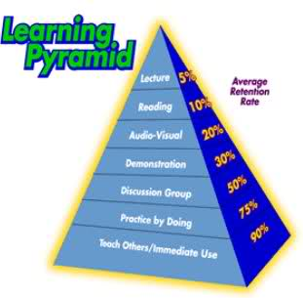
- Collaborative team work. This mainly achieved through web2.0 technologies and social networking tools . If you have read the UNESCO’S publication “ The four pillars of education “ you would realize that collaboration is the core element of the four pillars which are :
- Learning to know
- Lerning to do
- Learning to live together
- Learning to be
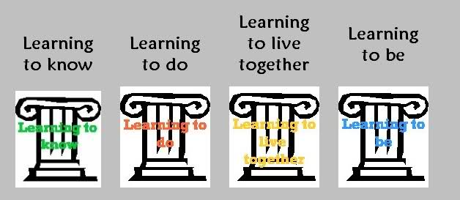
21st century pedagogy develops some particular kinds of fluencies in students :
- Technology fluency : know how to use technological tools
- Information fluency : know how to gather, process and validate information
- Media fluency : know how to view , select , and use media.
To conclude , here is a diagram provided by Andrew Churches that summarizes most of what we have talked about concerning the 21st century pedagogy features :
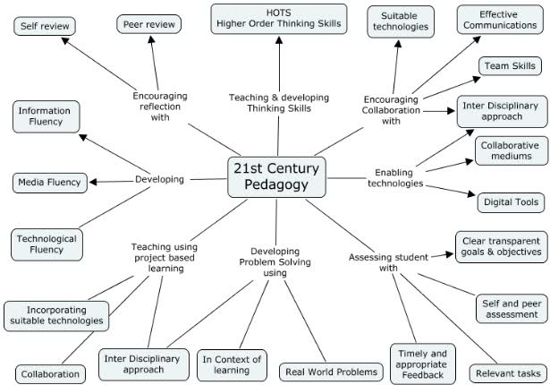
Watch this conclusive video to clear all your doubts about the 21st century pedagogy
21st pedagogy
That’s it about The 21st century pedagogy teachers should be aware of.

