PBL – the best teaching method in the 21st century instruction
11:38 AM 21st century teaching skills 0 comments Med
Let me start this article with what Obama says in a speech at the Center for American Progress :
“ Let’s be clear — we are failing too many of our children. We’re sending
them out into a 21st century economy by sending them through the
doors of 20th century schools.”
This is a true statement issued from the lips of a political person rather than an educator. There is a profound disconnect between what students are being taught and what the actual world is demanding of them as adults. It sounds like there exists two worlds one inside the school and the other outside. This double faced situation has a direct impact on today's educational landscape and therefore the workplace leading to “ the right person in the wrong place “ dilemma.

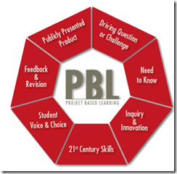

There is a huge need for a total reformation of school systems and curriculums to better fit in the 21st century education. Fortunately enough , some countries especially in the developed world have already taken the step and the results are quite reassuring, others are lagging behind but will soon join in for they can not stand against the current.
I have already talked in an earlier post about the 21st century education and skills teachers need to have and have clearly explained the correlation between those skills and students performance and today i am going to introduce you to a teaching ,or better say, instructional method that is called Project Based Learning. I hope you have already heard about it but if not then this is your chance to know it all.

Project Based Learning or PBL as they refer to it is
“ an instructional approach built upon authentic learning activities that engage student interest and motivation. These activities are designed to answer a question or solve a problem and generally reflect the types of learning and work people do in the everyday world outside the classroom.” taken from PBL Online
Projects and activities are the keys to a better understanding of PBL. They are no longer tasks that students need to finish after a traditionally-taught unit but rather a set of learning experiences and tasks that guide students in inquiry toward answering a central question, solving a problem, or
meeting a challenge. Research has clearly proved that projects that are well-designed and based on students experiences improves students motivation to learn, help them see how school connects to the outside world by making learning relevant and meaningful, and promotes greater civic participation and global awareness.
As a teaching method, PBL is the best means for educators to meet the objectives of the 21st century education that can be abridged in the 4Cs equation ( critical thinking, communication, collaboration, and creativity).

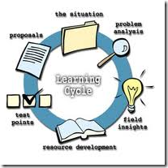
Some features of PBL
Here is a list of some features that characterize PBL as stated in bie.org :
PBL makes students focus on significant issues, debates, questions and/or problems through a central driving question or challenge.
It contextualizes learning and gives students driving motives and reasons to learn and understand the information and concepts before they apply them.
It requires inquiry to learn and/or create something new.
It requires critical thinking, problem solving, collaboration, and various forms of communication.
IT teaches students how to :
- use higher-order thinking skills
- learn to work as a team and contribute to a group effort
- listen to others and make their own ideas clear when speaking,
- be able to read a variety of material,
write or otherwise express themselves in various modes, and make effective presentations.
PBL increases students’ educational engagement by allowing them to make their own choices and take responsibility when doing so.
It lets students gain a deeper understanding of the concepts and standards at the heart of a project
Rigorous projects help students build vital workplace skills and lifelong habits of learning

These are in brief the main features of PBL . i hope you have grasped a general idea of what PBL is all about. Just remember that unless we incorporate the PBL method into the 21st century instruction we will never reach the 21st century educational goals.
if you want to learn more about PBL then here are some further links :
- bie.org
- Experts and newbies
- bbonline

