Bloom’s Taxonomy: The 21st Century Version
12:28 PM 21st century teaching skills 6 comments Med
So much have been written about Bloom’s taxonomy; one click in a search engine will flood your page with hundreds of articles all of which revolve around this taxonomy. Only few are those who have tried to customize it to fit in the 21st century educational paradigm. As a fan of Bloom’s pedagogy and being a classroom practitioner, I always look for new ways to improve my learning and teaching, and honestly speaking , if you are a teacher/ educator and still do not understand Bloom’s taxonomy then you are missing out on a great educational resource.
The following article is a summary and a fruit of my long painstaking research in the field of Bloom’s taxonomy. The purpose is to help teachers grow professionally and provide them with a solid informational background on how to better understand and apply Bloom’s taxonomy in classrooms in the light of the new technological advances and innovations..
Bloom’s taxonomy of learning as Wikipedia has put it is “ a classification of learning objectives within education proposed in 1956 by a committee of educators chaired by Benjamin Bloom ”. Although it received little attention when first published, Bloom’s taxonomy has since been translated into 22 languages and is one of the most widely applied and most often cited reference in education.
Bloom, being convinced of the importance of thinking behaviors in the processes of learnign, had spearheaded a group of brilliant educational psychologists to undertake the task of classifying educational goals and objectives. They first came up with a general framework which was turned later on to a taxonomy of 3 domains.
1 – The cognitive : The intellectual or knowledge based domain consisted of 6 levels . Associated with the verb to THINK
2 – The Affective : Emotional or attitudinal based domain and consists of 5 levels. It is associated with the verb to FEEL
3 – The Psychomotor : The physical or skills based domain and consists of 6 levels
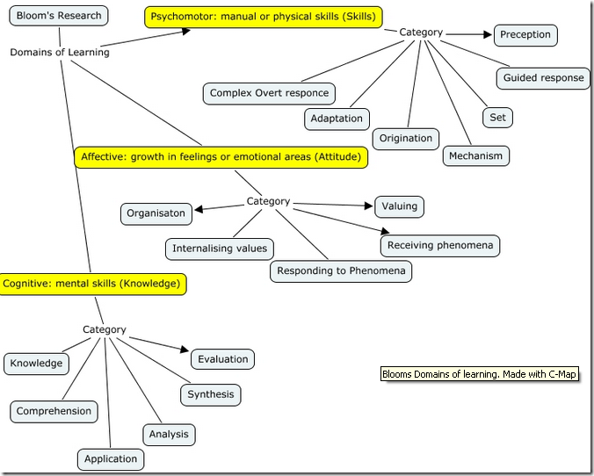
Bloom created different levels for both the cognitive and affective domains but never fully detailed the psychomotor domain leaving it for others to complete the task.
Let us now go through the different domains stated here. Apart from the diagram created by me and labelled after me all the other pictures and diagrams are taken from different sources. When you click on a picture it will direct you to its source.
1 The Cognitive Domaine
It involves knowledge and development of intelectual skills from Lower Order Thinking Skills (LOTS ) to Higher Order Thinking Skills ( HOTS ). They are arranged below in an increasing order from lower to higher order.
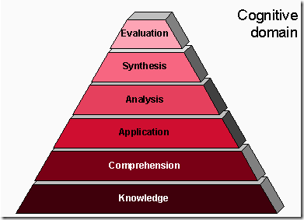
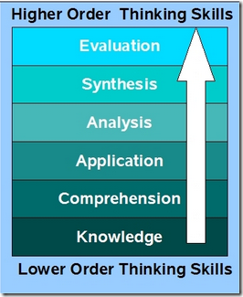
2 – The Affective Domain
Skills in this category describe the way people react emotionally and their ability to feel another living thing’s pain or joy. The five major affective categories are listed from the simplest behavior to the most complex.
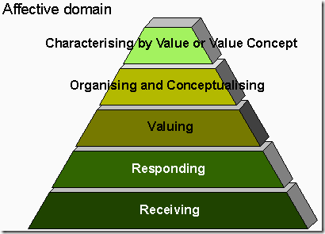
3-The Psychomotor Domain
Bloom did not create subcategories for the psychomotor domain but others such as Simpson, Harrow, and Dave have. They have added:
- Perception: The ability to use sensory cues to guide motor activity
- Set :Readiness to act. It includes mental , physical and emotional sets.
- Guided Response : Adequacy of performance is achieved by practicing.
- Complex Overt Response : The skillful performance of motor acts that involve complex movement patterns.
- Adaptation : The individual can modify movement patterns to fit special requirements
- Origination : Creating new movement patterns to fit a particular situation or specific problem
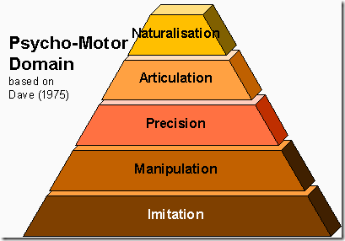
In each of the three domains, Bloom’s taxonomy is based on the premise that categories are ordered in degree of difficulty. An important premise of Bloom’s taxonomy is that each category or level must be mastered before progressing to the next. Accordingly:
- Before we can understand a concept we must remember it.
- Before we can apply the concept we must understand it
- Before we analyze it we must be able to apply it
- Before we can evaluate its impact we must have analyzed it
- Before we can create we must have remembered, understood, applied, analyzed and evaluated.
Blooms Revised Taxonomy ( BRT )
During the 1990s a new group of cognitive psychologists, lead by Lorin Anderson ( a former student of Blom’s ) and David Krathwohl updated the taxonomy reflecting relevance to 21st century education. In 2001, they published Bloom’s Revised Taxonomy with some changes. The changes occur in 3 main categories:
1 – Terminology
They changed the names in the six categories from noun to verb forms
2 – Structural Changes
Bloom’s original cognitive taxonomy was one dimensional form but with the addition of products , the Revised Bloom’s Taxonomy becomes a two-dimensional table
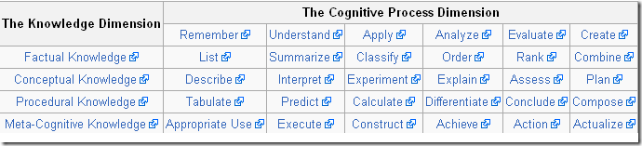
3 – Changes in Emphasis
The Revised Bloom’s Taxonomy places emphasis upon its use as a “ more authentic tool for curriculum planning, instructional delivery and assessment.”
This new taxonomy reflects a more active form of thinking and is perhaps more accurate.
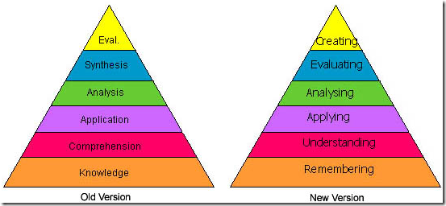
With the advance of technology into our lives and particularly into education , we started to talk about new emerging skills and competences that Bloom’s first taxonomy did not include. Below is a diagram i have created to include these new skills which corresponds to the 21st century learning.
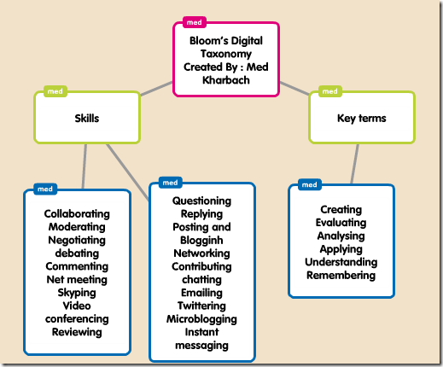
Blooms Taxonomy for iPads taken from iPad Applications in Bloom’s Taxonomy.
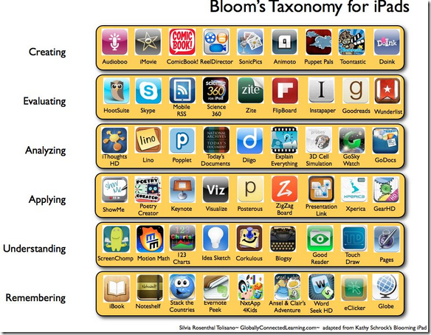
Google tols to supprt Bloom’s Taxonomy taken from Bloomin Google
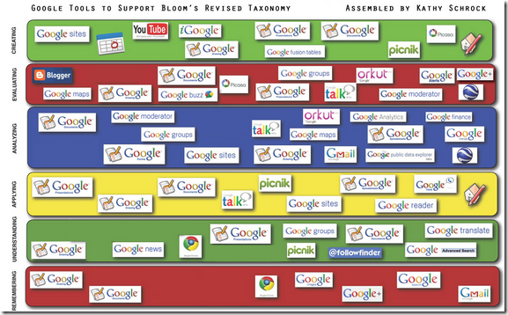
Here is a mdel of learning objectives taken from Iowa State University
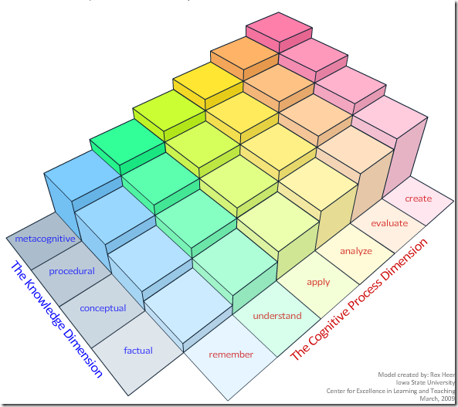

My Webliography:
Bloom’s Taxonomy Learning Domains
iPad Applications in Bloom’s Taxonomy
Analyzing Apps with Bloom’s Taxonomy
Bloom’s Taxnomy
Bloomin’ Google
Bloom’s Digital Taxonomy
A Model of Learning Objectives
Bloom’s Taxonomy of Learning Domains
Research Skills
Bloom’s Taxonomy Review
Bloom’s Taxonomy ; The University of Georgia
Bloom’s Taxonomy : Wikipedia

