The First Step in PRIME
Active Learning

Trainer’s Module

Developed by
William Tweedie

May – August 2012

Table of Contents
Introduction 3
The Prime Task 3
Description: 4
Objectives: 4
Materials: 4
Time: 4
Part 1 5
PRIME Active Learning and Activating Prior Knowledge – Theory 5
Activity 1 – Brainstorming PRIME 5
Activity 2 – Setting your Goals and Objectives 7
9 PRIME Reading Skills 8
Activity 3 – What is Prior Knowledge? 8
Video – Dr. Suzanne Clewell 11
Activity 4 – APK in EFL Contexts 12
Part 2 13
Activating Prior Knowledge in Developing Reading Skills 13
Activity 5 – Simple Word Poem 14
Activity 6 – Question Answer Relationships (QAR) 15
“Why Teenagers Find Learning a Drag.” 16
Activity 7 – Diamante Poem 19
Activity 8 – Compare and Contrast/Similarities and Differences 21
City Mice and Country Mice 21
Compare and Contrast Matrix Example 22
Compare and Contrast Matrix Form 23
Activity 9 – A Read Aloud 24
The City Mouse and the Country Mouse 24
Activity 10 – Shape Poems 26
Activity 11 – Elements of Thieves - A Strategy for Previewing Text 28
THIEVES: 29
Activity 12 – Building Vocabulary Cloze Reading 39
You Are Beautiful As You Are - Cloze 39
Activity 13 – Predicting 41
The Lion and the Mouse 41
References 45

Introduction
This workshop is intended for facilitators of learning (aka teachers) for upper primary, secondary and tertiary level educators. The activities in this module are directly applicable for upper primary and secondary students and they are intended to be adapted by tertiary educators across a broad field of subjects in a variety of learning settings. The accompanying file of facilitator’s aids contains active learning tools, such as The Muddiest Point, the 2-Minute Paper, Active participation worksheets, etc. from which the workshop facilitator can choose to use in helping to make the workshop as beneficial as possible for all participants.
Slide 1

The Prime Task

The Prime Task is intended to activate the participants’ prior knowledge about Activating Prior Knowledge.
It is important to let them know it is not a test because obviously they are in attendance to add to their existing knowledge and experience of Activating Prior Knowledge.
The task itself is a technique to activate prior knowledge.
This task sheet should be placed separately at each participant’s place for the facilitator to reflect on modification for future workshops.

Slide 2 Title Slide

Description:
The underlying theoretical concepts are briefly described in Part One of the workshop which contains activities that demonstrate the principles and set the stage for the Active Learning that will follow in the activities in Part 2.
It is important to let the participants know the activities are a small fraction of those available to them by searching on the Internet.

Objectives:
This workshop is primarily intended to give the participants practical experience in some of the many and varied strategies and activities in Activating Prior Knowledge and thereby reinforcing the importance of the theoretical underpinnings that are briefly outlined in the first section.
Learners will be exposed to or deepen their understanding of the principles of active learning and the essential role activating prior knowledge plays
Learners will learn about and be actively engaged in APK activities and thereby reinforce their knowledge and understanding of the role of APK especially in a reading instruction/facilitation process.
The facilitator should make the point early in the introduction to the workshop that most of the strategies they will practice are directly applicable to learning in any academic subject context or can be restructured to serve the same purpose.

Materials:
LCD projector – If the accompanying Activating Prior Knowledge PowerPoint presentation is used. (It’s not essential.)
Writing instruments – should be available if participants should happen not to have their own.
Workbooks – Most of the worksheets the participants will need are in the Participant’s Reference and Workbook. The Prime Task worksheet, the worksheets in Activity 13 – Predicting, and the complete story of “You Are Beautiful as You Are” in Activity 12 may be handed out separately as individual sheets (for research purposes); the reading material in Activity 11 may be substituted with more subject appropriate and relevant material depending on the workshop’s target audience.
Tables or seating arrangement – to accommodate groups of five (ideal); this can be modified as necessary

Time:
The workshop is intended to take two hours to complete. However, the facilitator may cut some activities if time constraints warrant or add activities if time permits.

Slide 3

Part 1

PRIME Active Learning and Activating Prior Knowledge – Theory

Activity 1 – Brainstorming PRIME

How to Brainstorm – the Rules:
1. Record every thought and idea very quickly. Each one has value.
2. A rapid flow of ideas is best.
3. Do not interrupt the flow to judge any thoughts or ideas. Record all thoughts even if they seem off topic, unrelated, or even dumb.
4. Remember that ideas that do not seem worth recording might prove to be important after all. At the very least, they may lead to other valuable ideas.
5. Brainstorming can be done alone, but the more people involved in the process, the more ideas will be generated.
6. Keep brainstorming until the ideas slow down. Take a deep breath, pause, and be ready to record some more ideas if time permits.
7. When the ideas finally seem to slow to a stop, look over what was generated.
8. Report the best ideas.

Procedure:
Discuss the rules briefly (1 minute) emphasising that NO comments and especially no discussion on the ideas is to be undertaken. Not even comments like: Oh! That’s a good one.”
If the group is large (more than 25 people) and seated in lecture style settings ask every second person in a row to work with the two people seated on either side of them. (Second, Fifth, Eighth, etc.) In these groups of three they can work together on the activities or tasks.
If the setting is more conducive to larger groups with tables to accommodate five members, have the groups of five work together. Ideally there will be groups of five members. (2 minutes)
Each group Brainstorms according to the rules what each of the letters in PRIME might mean for 5 minutes.
The facilitator may then discuss with the whole group the top three ideas each group presents for 2 minutes while the ideas are recorded on a whiteboard or flip chart. A consensus can then be reached, prioritising the ideas.

Time: 10 minutes +

Slide 4
The Facilitator briefly explains the meaning of the author’s PRIME Approach.
As the theoretical underpinnings of The Process Learning must be:
PRACTICAL – Doable and Doing (Active Learning)
Doable: If the bar is set too high, if students don’t understand and aren’t able to achieve the results expected of them, then they become demotivated and lose self-esteem.
Doing: Students must be at the fifth stage of engagement in order for learning to occur. They must be cognitively and often physically involved in the process. (Refer to the “Seven Levels of Engagement” model below.)
RELEVANT – Important or Significant to the Students (Fun is always significant)
If students don’t see or are not helped to see the connection of what they are learning as important to their personal lives, they will not see the need to learn it and will be uninterested.
INTEGRATED – Language Skills, Learning Styles, Background, Interest, Goals (BIG)
The teacher must know more than the names of their students. They must consider carefully the social context in which their students live, both in and out of school; the family circumstances; their previous learning experiences; the current level of language development; and how they learn, individually and generally as a class.
MEANING – Centered – Meaningful and Centered on Meaning
Rich and challenging but achievable content and the clear and effective conveyance of meaning (which may often be insignificantly flawed with grammatical or structural errors) must be the focus and intent of students and teachers. Errors are opportunities to learn important information that will clarify the intent and purpose of communication but must take second place to the conveyance of meaning. Feedback on errors must be immediate, consistent, and non-demeaning to the students.
ENRICHING – Engaging – Creating a Brighter Future
Students and teachers must always know and feel that the learning process is intended to enrich their lives, their families and communities, and humanity.
The Method is SID C ME – (Student Initiated, Directed, Controlled, Monitored, and Evaluated Learning) – only possible if students are given the responsibility for their own learning which comes with setting and achieving specific goals with the assistance and guidance of the teacher. The reward is seeing the benefit and enjoying the fun of learning. This is the subject of another workshop or course. However, for the purpose here it is important to make the point that setting goals (the top of the ladder students are metaphorically climbing) and objectives (each rung of that ladder) is vital to engagement and achievement in the learning process.
(Tweedie 1997-2003)
For more information visit: http://prime-learning.weebly.com

Time: 6 minutes

Activity 2 – Setting your Goals and Objectives

Procedures:
Ask participants to take a few minutes to consider individually why they are here, what they expect to learn, and how they will use that knowledge and experience in their teaching practice. They may want to refer to their thoughts expressed in the PRIME task to get them started. Use the form provided.

1. What is the specific ultimate goal of your participation in this workshop?
____________________________________________________________________________________________________________________________________________________________________________________________________________________________________________________________________________

2. What specific objectives have you set for yourself (the active achievable steps) you will take to achieve that goal?

A. _________________________________________________________________________________________________________________________________________________________________________________________________________

B.
_________________________________________________________________________________________________________________________________________________________________________________________________________

C.
_________________________________________________________________________________________________________________________________________________________________________________________________________

(Presseisen 1995)

Time: 4 minutes

Slide 5

9 PRIME Reading Skills

Facilitator explains the Reading Skills:

I2SQP4R U (I too See Quiet People forrr yoU) – Imagining, Skimming, Scanning, Questioning/Predicting, Reading Aloud, Reading Rate, Reading Rhythm, Research.
There are dozens of abilities or activities reading experts list in the literature. Just pick up any academic text to see.
However, I have concluded that they can all be grouped under one or more of these basic skills.

The only one you may not have come across in expert texts on reading is Imagining. It is a skill that can be guided and developed.

We hope to practice all the skills today in deepening our understanding of how important it is to Activate Students’ Prior Knowledge.

Time: 4 minutes

Slide 6

Activity 3 – What is Prior Knowledge?

The title of this workshop says it is the first step in PRIME Active Learning (PAL).
Let’s briefly look at what Active Learning is and what characterizes it?

Procedure:

Elicit 3-4 definitions or characteristics of AL from individuals in the group.

Have them compare their answers to the following description:
Active Learning is, in short, anything that students do in a classroom other than merely passively listening to an instructor's lecture. This includes everything from listening practices which help the students to absorb what they hear, to short writing exercises in which students react to lecture material, to complex group exercises in which students apply course material to "real life" situations and/or to new problems.
Paulson & Faust, California State University, Los Angeles, http://www.calstatela.edu/dept/chem/chem2/Active/index.htm

Time: 5 minutes

Slide 7
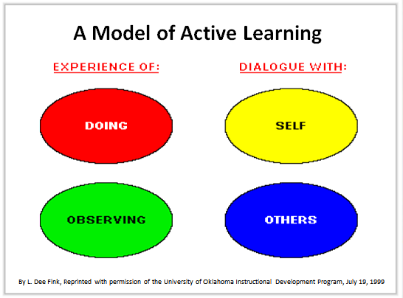
(Jantan 2010)
Procedure:

Show Fink’s Model of AL as in the slide 7 above.

Point out Dialogue and Experience as the means of acquiring knowledge and the elements of Dialogue are with SELF and with others.

APK must happen through dialogue with SELF whether stimulated by experience, observing or dialogue with others.

The next slide focuses on aspects of the SELF that must be activated in order to make sense of new information and upon which new information is constructed.

Time: 4 minutes

Slide 8

Procedure:

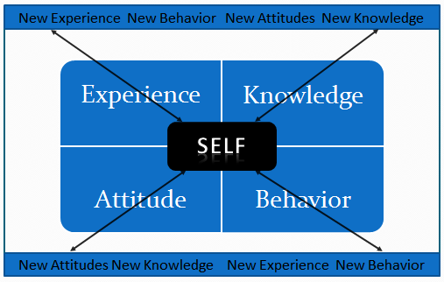
Explain that the following slide visualises the author’s original, extended framework to describe Prior Knowledge.
Elicit participants’ understanding of each concept: Experience, Knowledge, Attitude and Behavior

Convey the following information:

Prior knowledge is who we are as thinking beings. It is this SELF, “a composite of who we are, based on what we have learned from both our academic and everyday experiences” (Kujawa and Huske, 1995) that we bring to new learning situations.
Students learn and remember new information best when it is linked to relevant prior knowledge. Teachers who link classroom activities and instruction to prior knowledge build on their students' familiarity with a topic (Beyer, 1991) and enable students to connect the curriculum content to their own culture and experience. (Presseisen 1995)
Neglected in the literature is the relationship between ‘knowledge and experience’ and ‘attitude and behavior’. I postulate that the relationship is a critical one especially in the context of learning a new language where feelings are involved in the process to a greater extent than in any other learning. Language is at the heart of our ‘selves’. It is how we express who we are, our thoughts, desires, beliefs, aspirations and emotions. It is how others recognise who we are. Therefore it is necessary that we create a positive, supportive, safe and comfortable environment for our students. One essential means of doing this is to demonstrate to our students’ our understanding they are unique individuals whose prior knowledge is recognised as unique and is valued.
In summary, Experience and Knowledge are directly related to Attitude and Behaviour – in language learning particularly, it is common sense. For the average person, positive, progressive experience and knowledge lead to positive and progressive attitudes and behaviours. To understand and retain new information in what they are reading (the focus of this workshop), students’ need to connect this information to a framework of what they already know and understand, as you will hopefully experience in the activities that follow. (Tweedie 2012)

Time: 8 minutes

Slide 9

Video – Dr. Suzanne Clewell

Procedure:

Introduce the video. Reading Specialist Dr. Suzanne Clewell explains this idea with a very timely example. (Olympics 2012 are underway as I write this.) (Tweedie 2012)

Play the video.

Elicit comments or reactions from participants.

Transcript of the video:
"Activating prior knowledge is something that we do naturally as adult readers, as mature readers. We always relate what we're reading to something we know. As a matter of fact when we read we really have to think about those connections. Sometimes students don’t access their background knowledge because they never think that it's important or if they don’t have the background knowledge the teacher doesn’t have an opportunity to really build that background knowledge."

"If a student were reading about let's say Zeus and Greece and those first games on Mt. Olympus maybe the Olympics would never come to mind. But if there were a brief discussion in class about what the Olympics were, and most students can recall seeing at least one Olympics, that knowledge would help that student to understand the passage."

"So it's finding out if the students have the background knowledge. Then if they don't being able to expose them to some information that's going to help them to be able to think about those connections with what they're reading."
Dr. Suzanne Clewell – Video excerpt - 1.6 minutes
http://www.thinkport.org/career/strategies/reading/activate.tp

Time: 8 Minutes (slides 8 & 9)
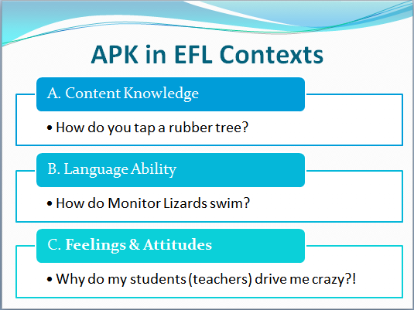

Slide 10

Activity 4 – APK in EFL Contexts

Procedure:

Ask the questions on the slide as they appear and explain that students may have the knowledge but not the language ability OR
They may not have the knowledge and therefor, the language ability in L1 must be such as to understand and learn the concepts needed and then learn the L2 equivalent.

If the student knows but can’t explain in English the teacher must be aware of this. L1 is therefore necessary to focus on building lexis and language ability. Many research studies have led to this conclusion. NOTE: However, we must always keep in mind the distinguishing elements among the ESL, ESL Immersion, and EFL contexts.
Feelings/Attitudes (the Affective Filter, as Krashen hypothesized) are absolutely critical in the process of L2 acquisition as discussed previously.

Time: 3 minutes
Now let’s get to the sampling of strategies and activities we selected for today.

Part 2

Activating Prior Knowledge in Developing Reading Skills

One Strategy is to use Poetry activities as part of the means to activating prior knowledge. Most of the activities in the workshop will include this technique.

Procedure:

Ask the participants how many of them teach or have taught teenagers? How many have teenage children?

Refer to the slide and ask if the picture activates their prior knowledge of the ‘dreaded’ teenager.
Ask the participants what their reaction to it is and what their general thoughts about teenagers are.

Time: 3 minutes

Slide 11
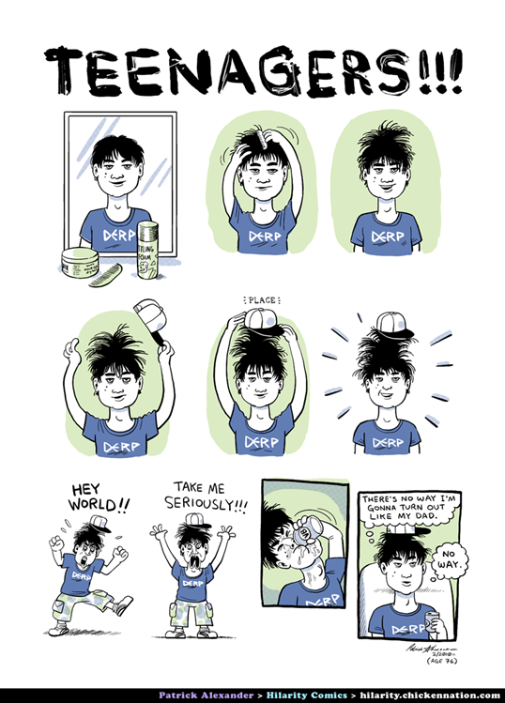

Slide 12

Activity 5 – Simple Word Poem

Procedure:
Ask participants to write individually a simple word poem about TEENAGERS. Follow the format on the worksheet.

Call on a few willing participants to share their poems with the group or collect a few and read them aloud making sure NOT to focus on any errors in spelling.

Time: 3 minutes

Word Poem
To create a word poem, use the poem frame below, which asks you to use different parts of speech to describe your topic.

______________________
Topic—a noun

______________________ _____________________ _______________________

adjective adjective adjective

______________________
verb

______________________ ______________________ ______________________
adverb adverb adverb

______________________ ______________________
New adjective New noun

Once students have focused on the topic and begun to activate what they have already experienced and know about it you can expand the range of what they know and extend this knowledge through other Activating Prior Knowledge and Knowledge Building activities. The next strategy, Question Answer Relationships (QAR) is good for informational or narrative texts.

Slide 13

Activity 6 – Question Answer Relationships (QAR)

Good readers pose questions before, during, and after reading. Being aware of HOW to gain information is just as important as the material that is actually gained. Remember—being a good reader involves thinking about how as well as what you read.

What kinds of questions should readers ask themselves when reading?

In the book Questions
A. Right There
It’s right there! The answer to this question can be found in one place in the text.

B. Think and Search
To arrive at the answer to this question, you need to piece together different parts of one or more texts from other sources.

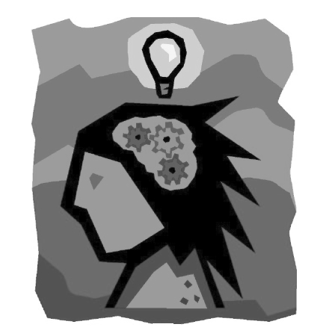
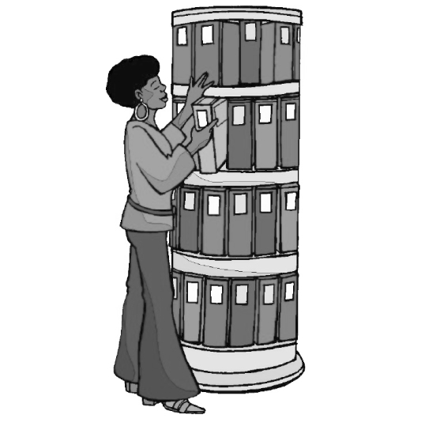
In my head Questions
A. On My Own
This type of question invites you to make a personal connection to something you have experienced or are experiencing.
B. Author and Me
The response to this question asks you to consider the author’s perspective/ position and your own experiences and views to formulate a response.

“Why Teenagers Find Learning a Drag.”

Procedure:

Explain the strategy as above.

Have participants read the article “Why Teenagers Find Learning a Drag.”

Then, ask them to develop their own questions from the text, using the QAR strategy.

Once they have finished, ask them to compare their answers to the following examples being sure to stress there are no right or wrong answers.

Slide 14

- In the Book:
  - What part of the brain is involved in learning?
- In my Head:
  - Can this explain (partly) my students’ attitudes and behaviours?
- Think and Search:
  - How is the hippocampus involved in learning?
- Author and Me:
  - Should I share this information with my students?

DO NOT include these questions in material give to the participants before the workshop as it will prejudice their own discoveries.
Time permitting; a group discussion of these relevant questions (questions 2 & 4) may ensue.

Time: 12 minutes

Why teenagers find learning a drag
- 14:09 19 March 2010 by Jessica Hamzelou
- For similar stories, visit the http://www.newscientist.com/topic/teenagers and http://www.newscientist.com/topic/Brain Topic Guides
Being a teenager can be a drag. As if dealing with peer pressure and raging hormones weren't hard enough, your ability to learn new things is also reduced. Now the brain molecules behind this learning deficit have been identified in mice - and blocked.
When children hit puberty, their ability to learn a second language drops, they find it harder to learn their way around a new location and they are worse at detecting errors in cognitive tests.
Why is this? Sheryl Smith and her colleagues at the State University of New York now reckon that all of these behavioural changes could be due to a temporary increase in a chemical receptor that inhibits brain activity in an area responsible for learning.
In 2007, Smith's team discovered that the number of these receptors soared in mice when they hit puberty, before falling back in adulthood. In their latest study, Smith's team set about finding out if these receptor changes in mice might lead to impaired learning abilities, rather like those seen in pubescent humans.
Shocking memory
The group examined the hippocampus – a region known to be involved in learning – in mouse brains. Sure enough, pubertal mice had seven times as many of the receptors as infant mice. In adulthood, the number of these receptors fell back to an intermediate level.
The team was also able to examine individual neurons and could see that the extra receptors were being expressed specifically at "neural projections" – sites within the hippocampus known to be involved in learning. This was further evidence that the increase in receptors might affect learning.
Finally, the group measured spatial learning abilities in the mice. The creatures were placed on a rotating platform, on which a stationary section delivered a mild electric shock. After a single shock, the infant mice learned to dodge the danger zone. The pubertal mice, however, failed to learn to avoid it even after several rounds.
Smith reckons that the same mechanism might underlie the learning deficits teenagers experience. Cheryl Sisk at Michigan State University at East Lansing agrees that "mouse puberty is similar to human puberty, although the timescale is different".
Learning restored
"The research adds to the growing body of literature indicating that puberty and adolescence are a unique period of nervous system development," says Sisk. "Adolescents aren't just in between children and adults. Their behaviour is different from both."
In a further experiment, Smith found that she could remove the learning deficit by injecting pubertal mice with THP – a stress steroid. In children and adult humans, THP is naturally released in response to stress. It reduces brain activity and calms you down, says Smith. But in pubertal mice, THP has the opposite effect – increasing their stress.
Smith suggests that in her most recent experiment, giving extra THP to pubertal mice similarly increased their brain activity and that this activity may have compensated for their learning deficits.
If similar mechanisms underlie teenage learning deficits in humans, this result might point to ways to deal with them - either through behavioural changes or drugs.
Smith suggests that a synthetic form of THP could be developed for teenagers with learning difficulties, although she acknowledges that care would need to be taken not to create any new problems. "We would have to be careful not to affect their mood," she says.
Sisk cautions that it's too soon to apply the results to humans or to other types of learning outside the spatial type tested in the mice.

Journal reference: Science, DOI: 10.1126/science.1184245 www.newscientist.com

Participants may use the QAR Rubric in their workbooks to gauge their success with this strategy.

Activity 7 – Diamante Poem

Procedure:
Review the structure of the Diamante Poem below and show the example Diamante Poem that follows about Reading: Noun, 2 Adjectives, 3 Verbs, 1 phrase, 3 more Verbs, 2 Adverbs, a similar, associated or contrasting Noun. (Slide 15)
Ask participants to complete the poem form in their workbooks using the topic of MICE. Ask them to complete their poem using words that come readily to mind, i.e., not to spend too much time trying to recall difficult words; remembering that the purpose of all the activities is to activate their individual existing knowledge/experience/attitudes about MICE.

Diamante Poem
To create a diamante poem, use the poem frame below, which asks you to use different parts of speech to describe your topic.
______________________
Topic—a noun

______________________ ______________________
adjective adjective

______________________ ______________________ ______________________
verb verb verb

____________________________________________________________________
Four-word phrase

______________________ ______________________ ______________________
Verb verb verb

______________________ ______________________
Adjective adjective

______________________
renaming noun

Time: 3 minutes

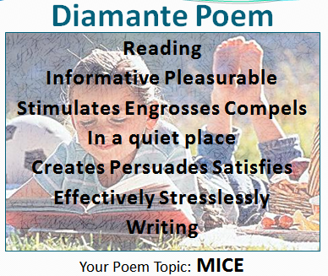

Activity 8 – Compare and Contrast/Similarities and Differences

City Mice and Country Mice

Procedure:

Have participants examine the Compare and Contrast Matrix example and worksheet that follow.

After determining their choice of categories, have participants use the worksheet to compare and contrast their ideas about City Mice and Country Mice.

They may also compare Similarities & Differences using a matrix like the following:

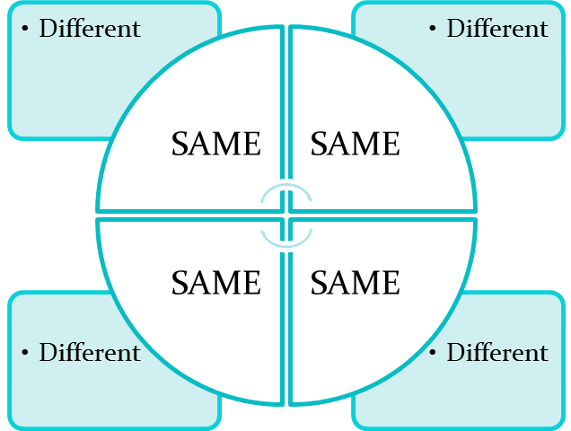

Time: 6 minutes

Compare and Contrast Matrix Example

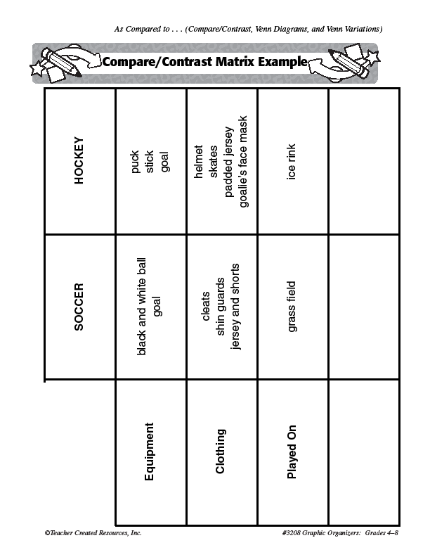

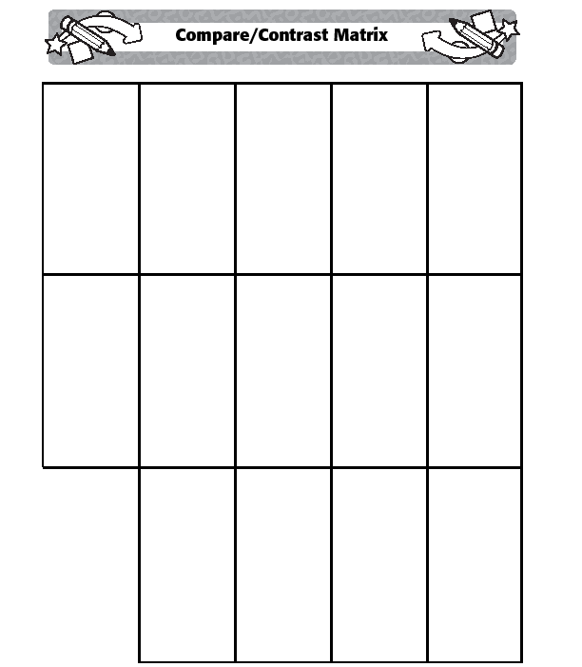

Compare and Contrast Matrix Form

Activity 9 – A Read Aloud

Slide 17

The City Mouse and the Country Mouse

Procedure:

Explain that APK should involve more than words. In language teaching it involves hearing the sounds, rhythm, stress, intonation of words, as well as the other senses of touch, taste, smell and sight. Reading Aloud is one of the most effective strategies because students must Imagine or construct images based on what they hear and see the reader do. These aspects can be valuable clues to meaning as well.

There are many ways of conducting Read Alouds with learners. In these circumstances, it depends to a great extent on the language level of the workshop participants.

Ideally the facilitator will model the reading with as much dramatic emphasis as possible.

Then have a member of each group repeat the reading to his or her own group. This allows for discussion and clarification of vocabulary, concepts, and interpretation of various aspects of the story.

Aesop’s Fables are perfect for finding and discussing the moral of his stories and their applicability to students’ lives.

Time: 5 minutes

Read Aloud Story: The City Mouse and the Country Mouse

There once was a mouse who liked his country house until his cousin came for a visit.
"In the city where I live," his cousin said, "we dine on cheese and fish and bread. Each night my dinner is brought to me. I eat whatever I choose. While you, country cousin, work your paws to the bone for humble crumbs in this humble home. I'm used to finery. To each, his own, I see!"
Upon hearing this, the country mouse looked again at his plain brown house. Suddenly he wasn't satisfied anymore. "Why should I hunt and scrape for food to store?" he said. "Cousin, I'm coming to the city with you!"
Off they went into the fine town house of the plump and prosperous city mouse.
"Shhh! The people are in the parlor," the city mouse said. "Let's sneak into the kitchen for some cheese and bread."
The city mouse gave his wide-eyed country cousin a grand tour of the leftover food on the table. "It's the easy life," the city mouse said, and he smiled as he bit into a piece of bread.
Just as they were both about to bite into a chunk of cheddar cheese, in came the CAT!
"Run! Run!" said the city mouse. "The cat's in the house!"
Just as the country mouse scampered for his life out of the window, he said, "Cousin, I'm going back to the country! You never told me that a CAT lives here! Thank you, but I'll take my humble crumbs in comfort over all of your finery with fear!"

Heather Forest - Story Arts http://www.storyarts.org

Activity 10 – Shape Poems

The words below (slide 18) are suggestions that relate to the content of activities to follow thereby activating some prior knowledge. The suggestions are ideally for a group of 25 participants. This can be adjusted as needed or warranted by the group. Content and number will change according to the group’s size and facilitator’s choice of subject matter.

After explaining the procedures in the excerpt that follows on the next page assign one of the words groups below to each participant group.

Ask each member of the groups to choose a different word from the following word groups assigned by the facilitator to create a shape poem:

Group 1 Group 2 Group 3 Group 4 Group 5
- Frog bear bananas flower pond
- Hornbill rabbit milk pear armadillo
- Monkey cow carrot egg leaf
- Lizard snake cheese bean root
- Mouse cat rice potato raindrop

(Detailed procedure for creating the word poems follows in the extracted text below.)

Point out to participants they have an extended description in their workbooks for reference.

Time: 10 minutes

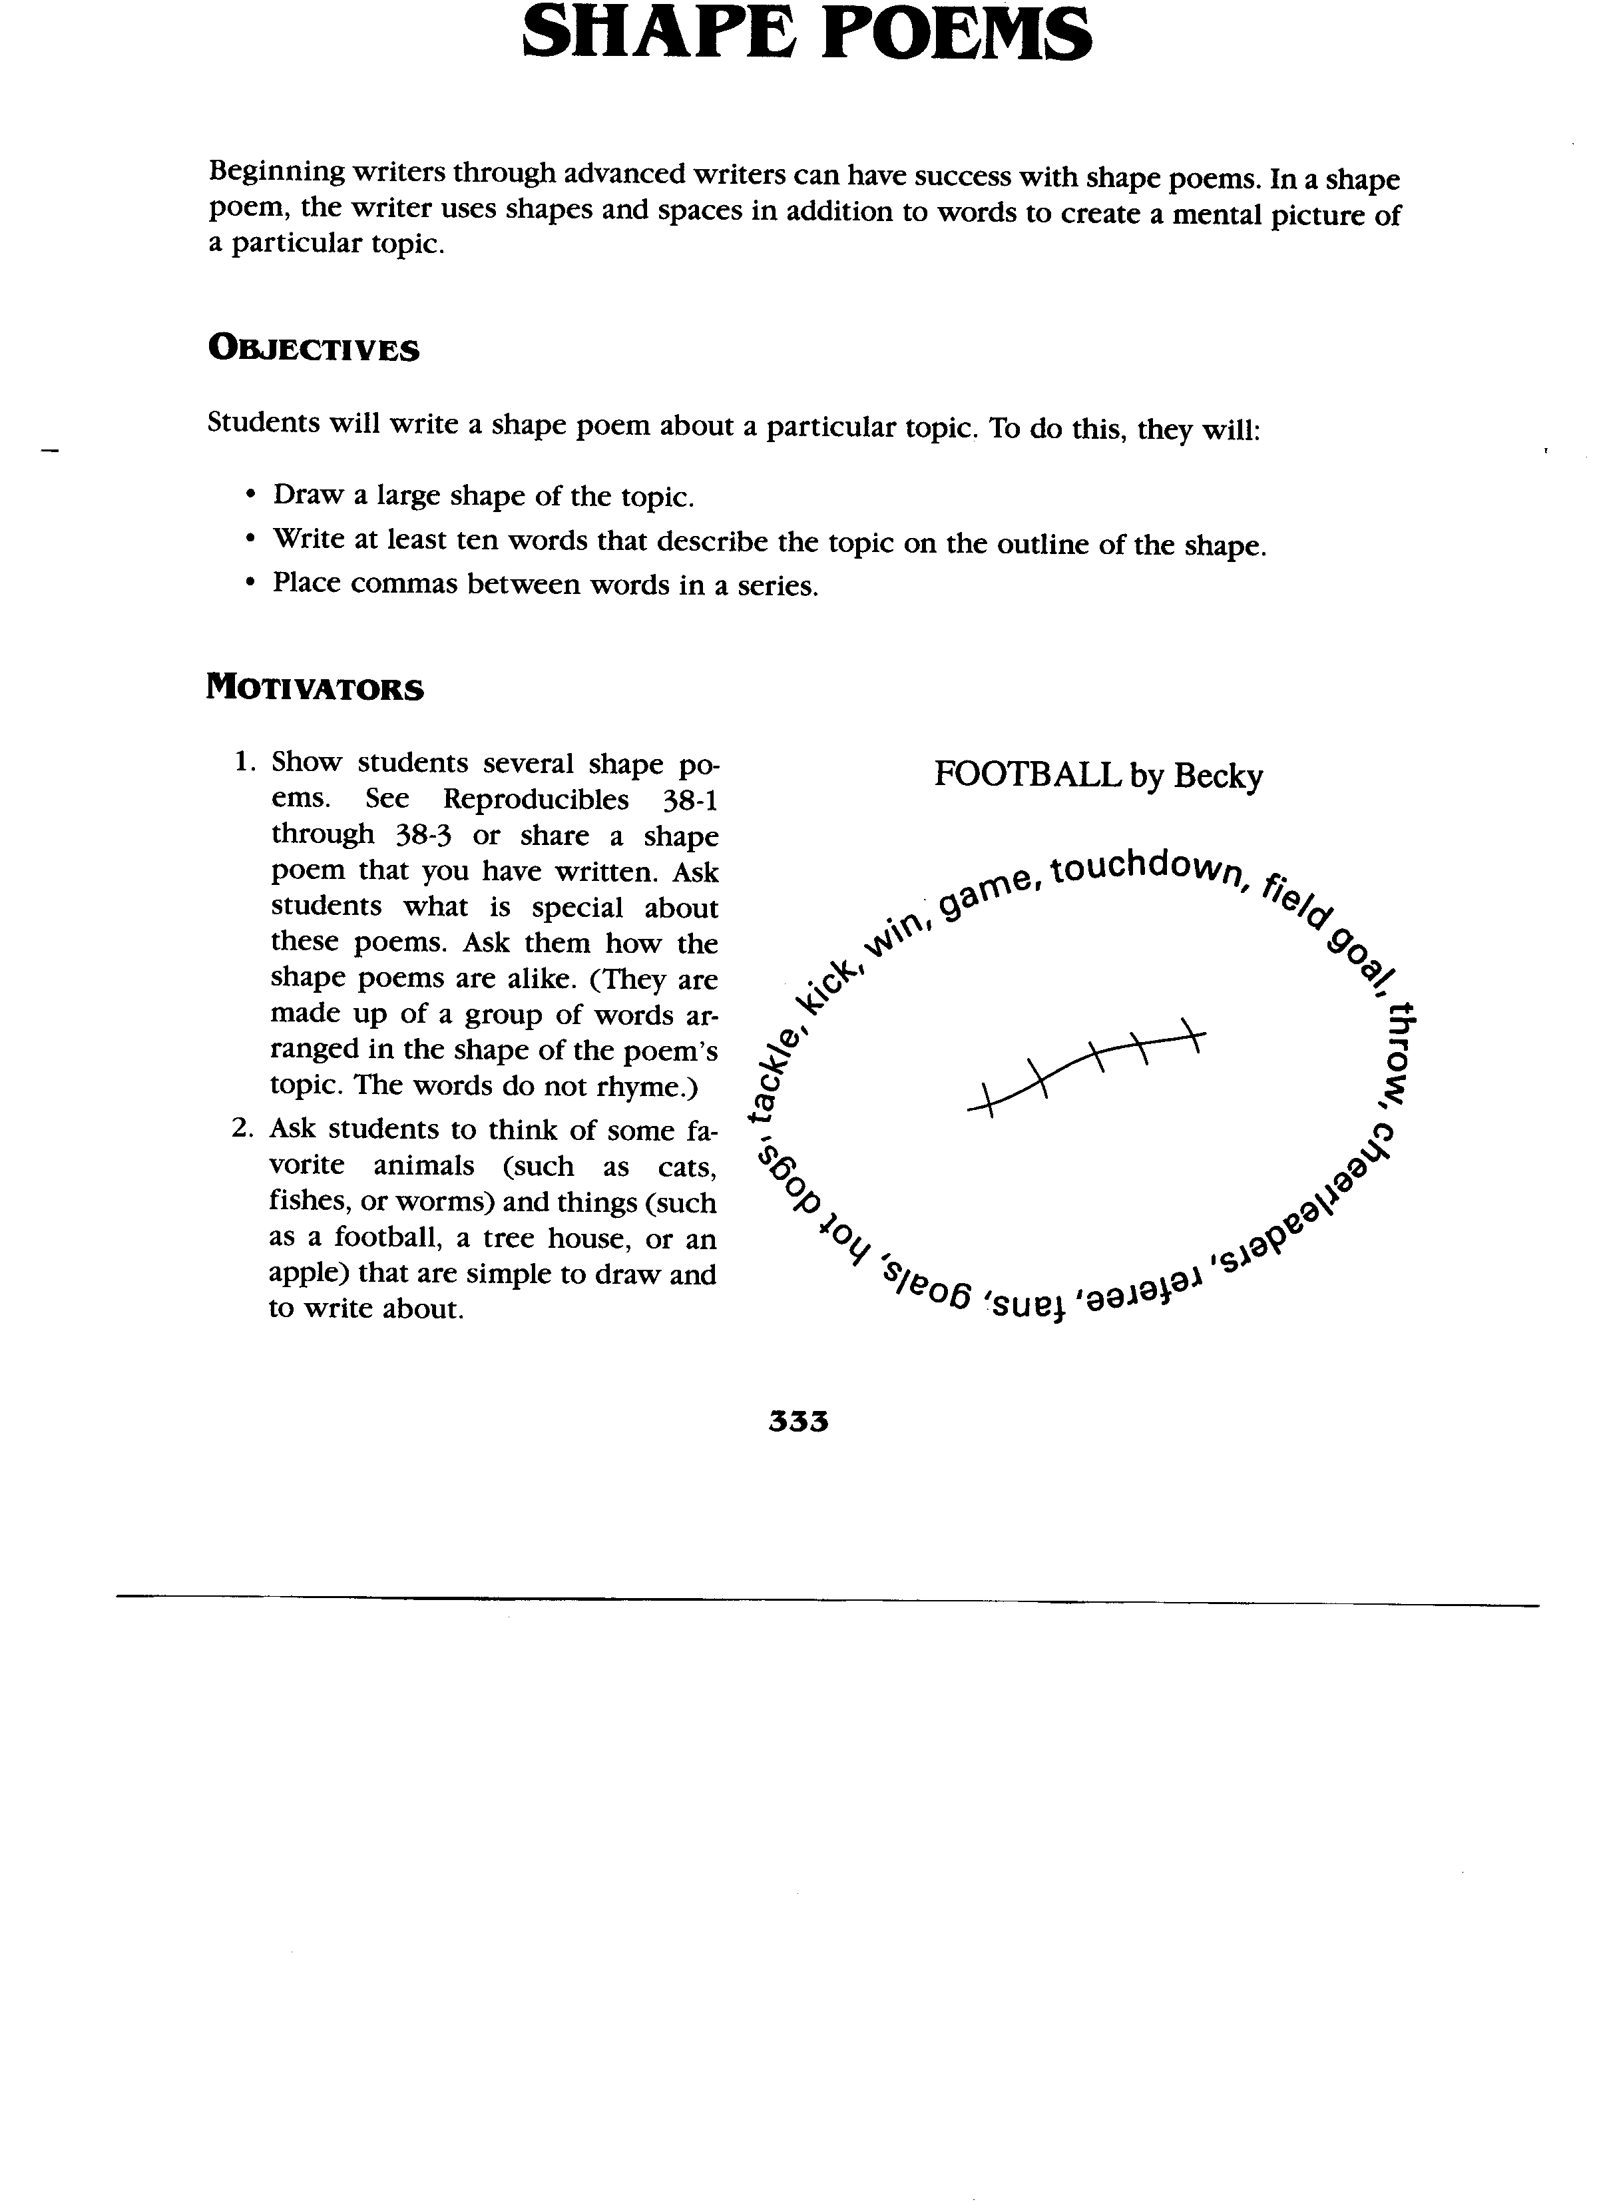

Activity 11 – Elements of Thieves - A Strategy for Previewing Text

Procedure:

Have the participants read the following description of the THIEVES strategy.

Using this strategy, have them apply it to reproduced copies of the texts that follow.

Important note: The topics chosen for the word poems above are meant to activate prior knowledge related to the readings copied here. The topics and readings can and SHOULD be adapted to the needs and interests of workshop participants.

After reading their texts, ask participants to share the gist of the information with their group members.

While each member of a group is sharing their information, other members should formulate 2 or 3 questions about the topic.

After everyone in the group has shared their information, each member of the group takes a turn, asking the individual presenters questions they have developed for each topic.

One member asks one set of questions of another member then another member takes his/her turn until everyone has asked a question(s) of every other member. This can be adapted by having questions asked by each member of one other member of a group only if time is limited.

THIEVES:
This activity will help students with comprehension by allowing them to preview the text structure in an organized manner. This pre-reading strategy will allow students to “steal” information before they actually begin reading the chapter. Students will survey the text in the following manner:

Title – Students sometimes skip the title, but it provides valuable information by establishing the topic and the context of the chapter. If the text is written in chronological order, the title may indicate where the chapter would fit on a timeline. Some questions that the student may ask while looking at the title include:
- What do I already know about this topic?
- How does it connect to the previous chapter?
- How can I turn this title into a question to focus my reading?

Headings – Headings indicate the important sections of the chapter. They help students identify the specific topics covered. Students can turn the headings into questions to create a more focused look at information covered in the chapter. Some questions that the student may ask while looking at the headings include:
- How does this heading let me know what I will be reading about?
- What topic will be discussed in the paragraphs below this heading?
- How can I turn this heading into a question that can be answered when I read this section?

Introduction – The introduction provides an overview of the chapter. It may come after the title and before the first heading. Sometimes the goals and objectives of the chapter are stated in the introduction. Some questions that students may ask when previewing the introduction include:
- Is the introduction marked or do I have to locate it?
- Does the first paragraph introduce the chapter?
- What important information will I find in the introduction?
- Do I already know anything about this?

Every first sentence in a paragraph – First sentences are often the topic sentences of the paragraph, and by reading these a student can get an idea of the information that will be contained in the chapter.

Visuals and Vocabulary – Students should look at all pictures, charts, tables, maps and graphs contained in the chapter. They need to read the captions and labels on each. This enables students to learn a little about the topic before they begin to read. Some questions that students may ask about the visuals include:
- How do these visuals relate to the content of this chapter?
- What can I learn from them?
- How do the captions help me understand the visual?
Vocabulary unlocks the meaning of the content. Students need to understand vocabulary in order to comprehend the text. Vocabulary may or may not be identified as key words. It might be highlighted or italicized in the text. Some questions that students may ask about the vocabulary include:
- Is there a list of key words and are they defined in the glossary?
- Are there important words in boldface or italics?
- Do I know the important words?
- Are there other words I don’t know?

End-of-Chapter (text) Questions – These questions indicate important points and concepts from the chapter. Just reading these questions will help students target information that is important in the text and establish a purpose for reading. Some questions that students may ask about the end-of-chapter questions include:
- What do these questions ask?
- What information will be important in this chapter?
- How do I locate this information in the text?

Summary – Many texts contain a summary at the end of the chapter. Students can read the summary to activate prior knowledge and give them an idea of the important concepts contained in the chapter.
THIEVES was created by Suzanne Liff Manz, an educational therapist and instructor at Nassau Community College in Garden City, NY. It was published in The Reading Teacher Volume 55 Number 5 in February, 2002.

Time: 15 minutes

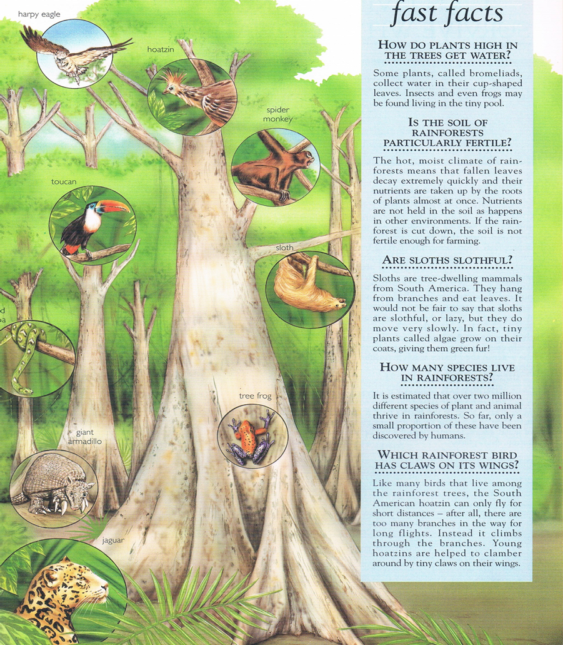

Group 1 or 5

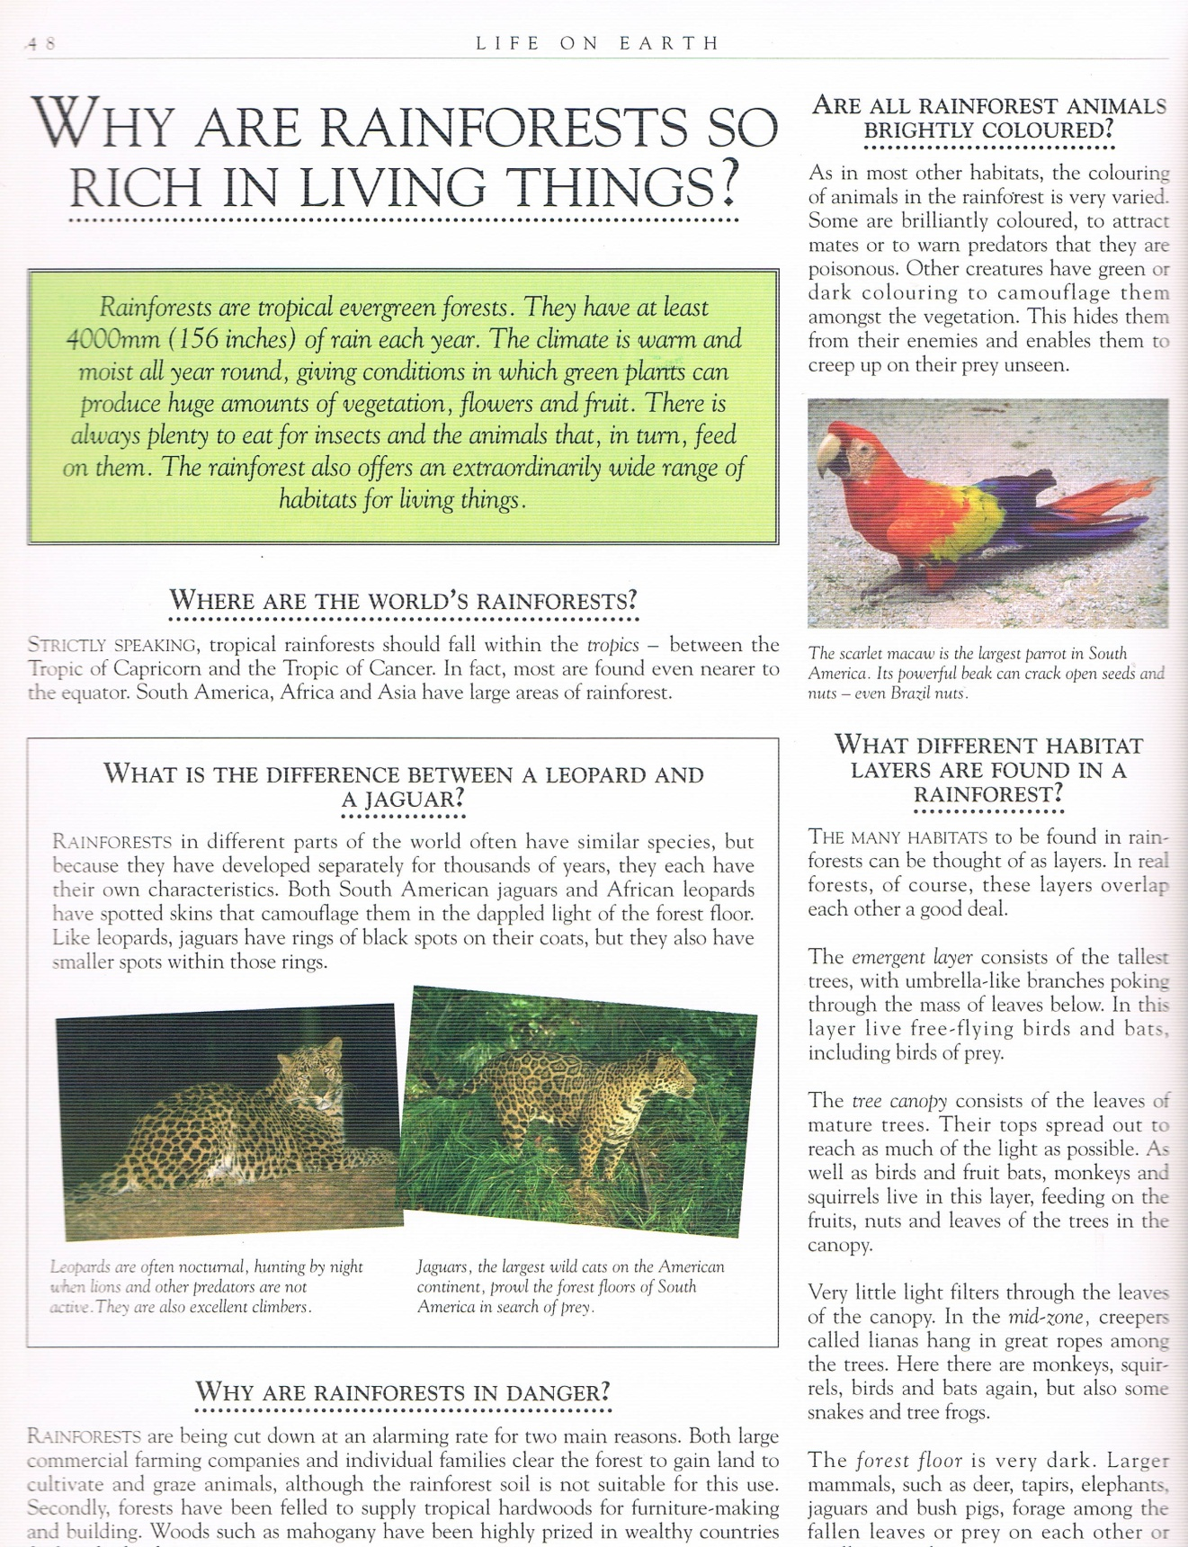
Group 1 or 5

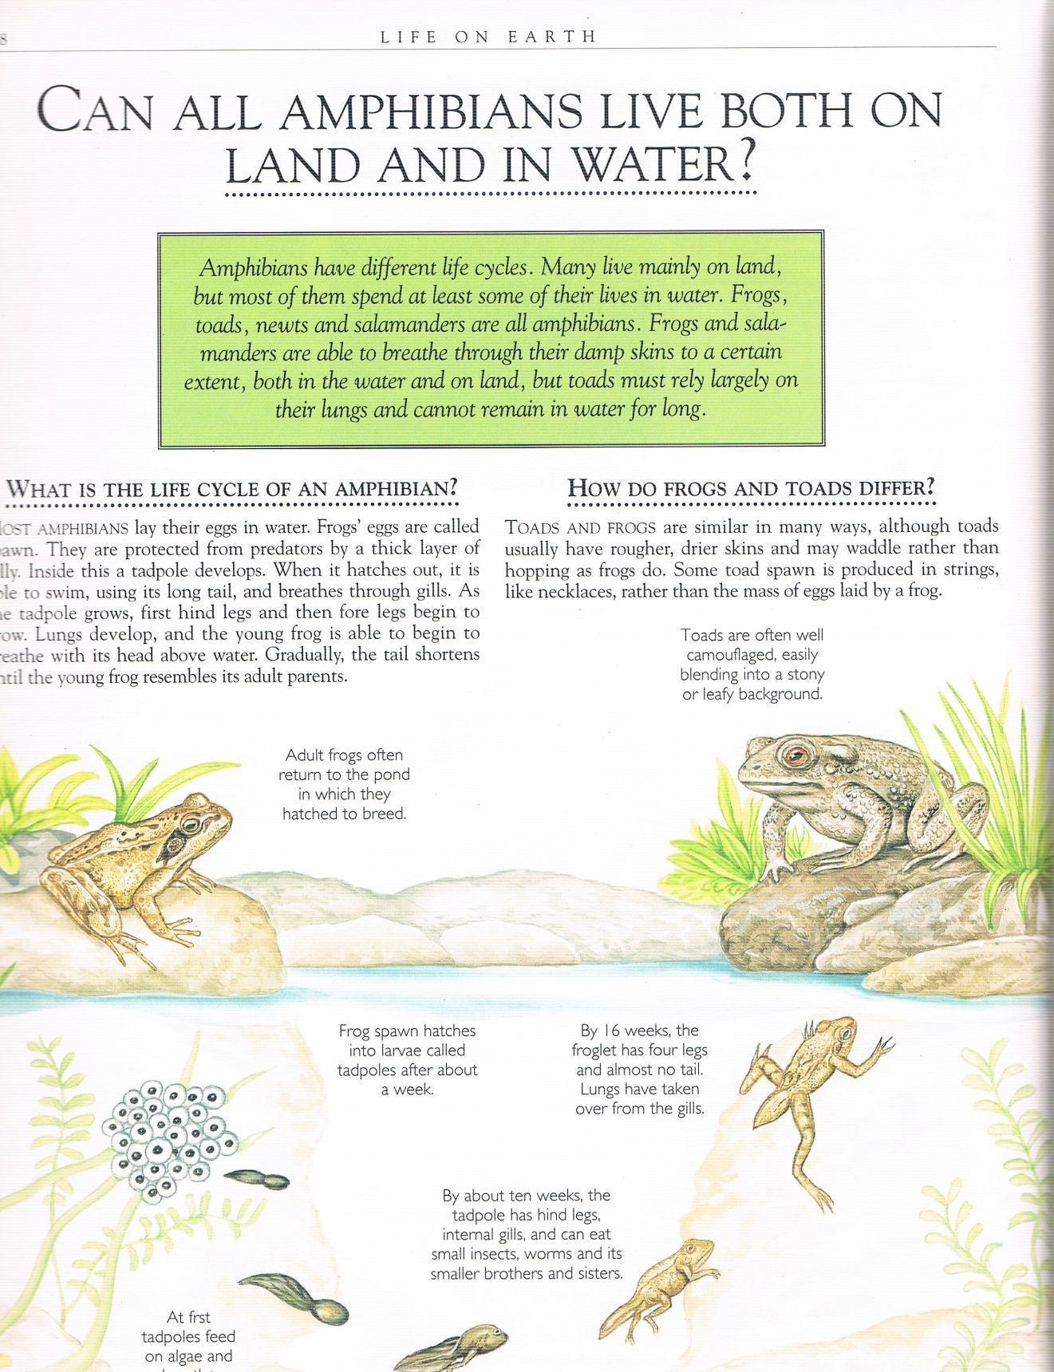
Group 1 or 2

Group 2 or 5
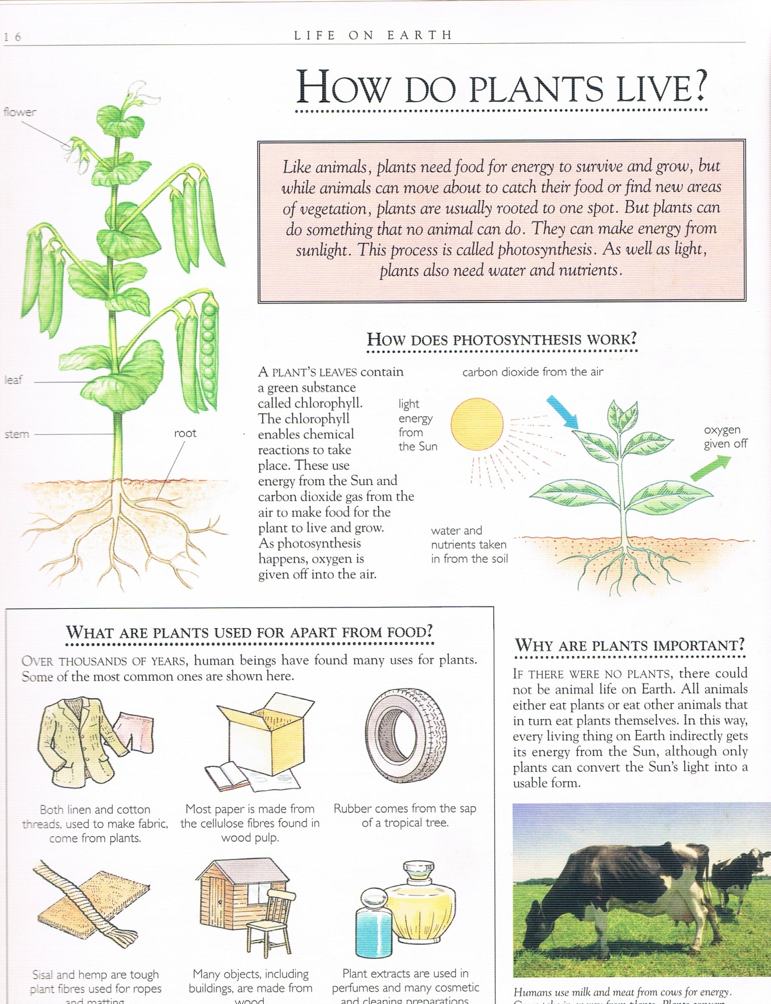

Group 2 or 4

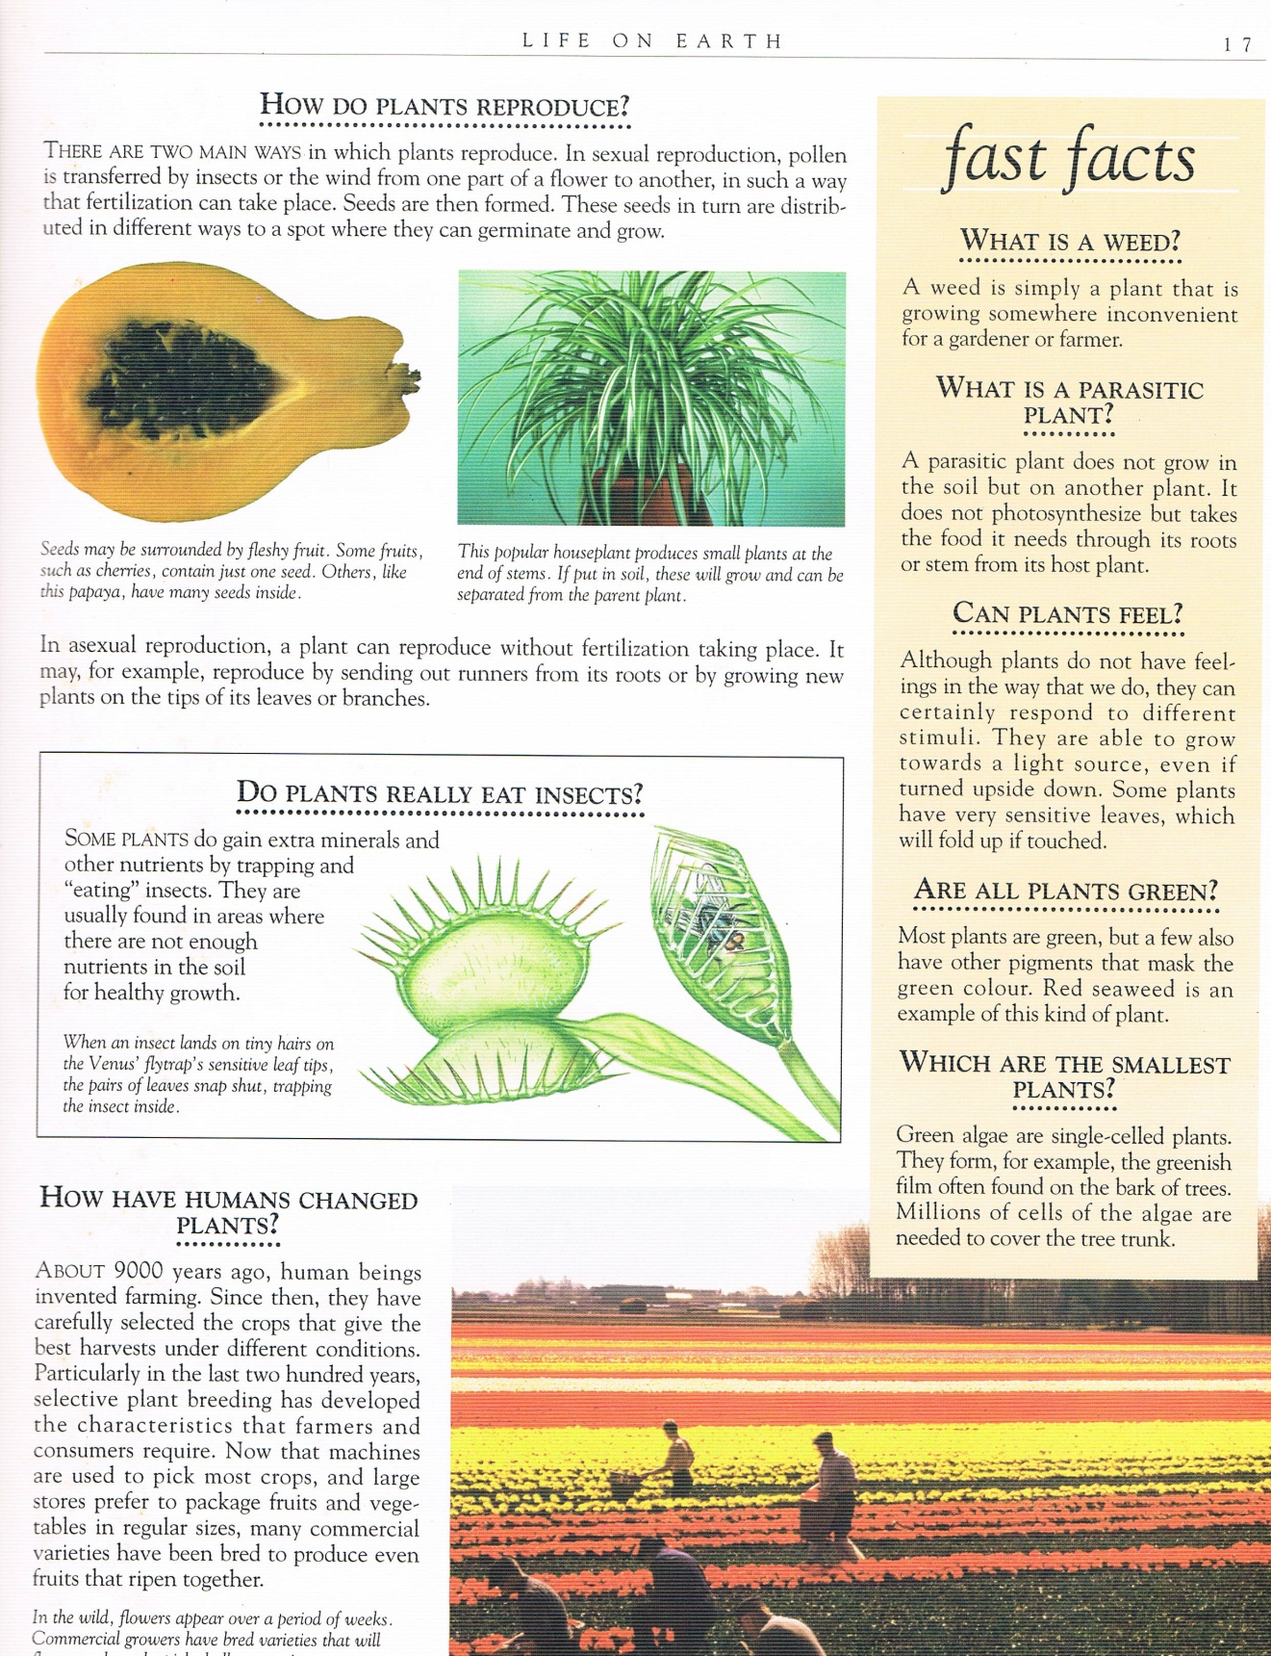
Group 2 or 4

Group 1 or 2

Group 3 or 4

Activity 12 – Building Vocabulary Cloze Reading

You Are Beautiful As You Are - Cloze

Procedure:

Ask the whole group if they are familiar with this Aesop Fable. If they are, they can use their imaginations and memories to complete the cloze reading worksheet (option 1 below). If they are not, include the word box for them to use.

Ask participants to complete the cloze reading in their workbooks.

Depending on the language level of the participants, (option 1) the facilitator may decide not to include the word box so members can use their imaginations and the bank of words they have in memory, to complete the story or (option 2) they may fill in the blanks from the word box included on the worksheet.

Time: 5 minutes

Cloze Reading of You Are Beautiful as You Are

There was once a crow who did not like his feathers.
"I wish I were a ______________!" he would say.
"You are _____________ as you are!" the other crows insisted.
"How plain and dull you seem to me!" he'd complain, and fly off to _________ peacocks.
The peacocks __________ __________ with their _____________l tail feathers outstretched. To the delight of the crow, some of the peacock feathers lay on the ground when the peacocks left.
Crow _________ _________ to the ground and ___________ the feathers into his ____________ ____ ________. He ______________ a few sticking up from his head.
"Now I am as beautiful as a peacock," he said.
But, when he went to join them in their strutting, the peacocks _________ him and pecked him. What a fuss!
"You are not a peacock," they said, "Don't ___________ us!"
Bruised and still ____________ some broken peacock feathers in his tail, he returned home.
After all his ___________, no one wanted his ____________!
As he sat ____________, the other crows said, "It's foolish to try and be what you're not. Learn to _______ the feathers you've got!"

1. strutted about 2. admire 3. flew down 4. beautiful 5 stuck. 6. insults
7. company 8. love 9. peacock 10. colorful 11. attached 12. poked
13. imitate 14. pecked 15. alone 16. dull 17. feathers 18. wings and tail
19. dragging 20. foolish
If you can’t fill in a blank with a word here, make up a work that fits!

You Are Beautiful As You Are – Complete text
There was once a crow who did not like his feathers.

Activity 13 – Predicting

The Lion and the Mouse

Procedure:

Ask participants if they are familiar with the Aesop fable with this title. If the majority are, then ask them to follow the directions below and write only an alternate version of the Fable. If they are not, then they can proceed with the options presented.

Present the following worksheets one by one to the participants for them to predict and write the next section of the story.

Explain the story is in three parts. The first introduces the characters and the first interaction between them which creates a conflict situation.

Participants then write their version of the next part which should develop a scenario of what happens next.

After everyone has completed their version of the next ‘episode’ give them the second sheet to compare their version with the original part of the Aesop fable.

They can then modify their version according to information in the original story or they may continue with their own versions.

When everybody has completed their stories ask them to compare while sharing their versions individually, commenting as appropriate.

Time: 15 minutes

___________________________________________________________________
Part 1
A small mouse crept up to a sleeping lion. The mouse admired the lion's ears, his long whiskers and his great mane.
"Since he's sleeping," thought the mouse, "he'll never suspect I'm here!"
With that, the little mouse climbed up onto the lion's tail, ran across its back, slid down its leg and jumped off of its paw. The lion awoke and quickly caught the mouse between its claws.
Continue writing the story as YOU imagine it here:

___________________________________________________________________
Part 2
"Please," said the mouse, "let me go and I'll come back and help you someday."
The lion laughed, "You are so small! How could ever help me?"
The next day, two hunters came to the jungle. They went to the lion's lair. They set a huge rope snare.
When the lion came home that night, he stepped into the trap.
Now based on what YOU PREDICTED or on the above continue writing the story here:

___________________________________________________________________
Part 3
He roared! He wept! But he couldn't pull himself free.
The mouse heard the lion's pitiful roar and came back to help him.
The mouse eyed the trap and noticed the one thick rope that held it together. She began nibbling and nibbling until the rope broke. The lion was able to shake off the other ropes that held him tight. He stood up free again!
The lion turned to the mouse and said, "Dear friend, I was foolish to ridicule you for being small. You helped me by saving my life after all!"

The End

Compare your predictions with the true story and with the versions which other group members have written. Which do you like the best? Why?

The facilitator should briefly recap the main points of the workshop and ask the group for comments or hand out a workshop assessment sheet.
Thank them for their active participation. Time: 2 minutes
This concludes the workshop. Total planned time: 120 minutes

References

Baxter, N 1997 1000 Questions and Answers Leicester Bookmart Limited
Clewell S. 2012 Activating Prior Knowledge – Video excerpt – downloaded March 2012 from http://www.thinkport.org/career/strategies/reading/activate.tp
Fink L. D. 1999 Active Learning Oklahoma University of Oklahoma Instructional Development Program
Jantan J. 2010 Student-Centered Learning Active Learning and Compilation of Best Teaching Practices Shah Alam Universiti Teknologi MARA
Forest H. Aesop’s ABC Ancient Fables Retold purchased and downloaded from http://www.storyarts.org
Hamzelou J. 2010 “Why Teenagers Find Learning a Drag.” extracted from: http://www.newscientist.com/topic/Brain Topic Guides Journal reference: Science, DOI: 10.1126/science.1184245 www.newscientist.com
Krashen, Stephen D. Second Language Acquisition and Second Language Learning. Prentice-Hall International, 1988.
Paulson D. R. and Faust .J L. Active Learning For The College Classroom Paulson & Faust, California State University, Los Angeles, Extracted from: http://www.calstatela.edu/dept/chem/chem2/Active/index.htm
Presseisen, B. Z. 1991. Thinking skills: Meanings and models revisited. In A.L. Costa (Ed.), Developing minds: A resource book for teaching thinking (rev. ed). Alexandria, VA: Association for Supervision and Curriculum Development.
Sunflower, S. 2006 Really Writing, San Francisco: Jossey Bass A Wiley Imprint downloaded from: http://www.teachervision.fen.com/poetry/printable/5418.html?
Tweedie W. M. 2012 A Model of Activating Prior Knowledge for Facilitators of Learning Kuala Terengganu IPGKDRI unpublished
Tweedie W. M. 2003 The PRIME Approach to Facilitating English as a Foreign Language Acquisition MA Thesis unpublished. Summary online at http://prime-learning.weebly.com

