The First Step in PRIME
Active Learning

Participant’s Reference & Workbook

Developed by
William Tweedie

May – August 2012

Table of Contents

PRIME TASK Worksheet 3
PART 1 – Theory 4
Activity 1 – Brainstorming PRIME 4
Activity 2 – Setting your Goals and Objectives 5
9 PRIME Reading Skills 6
Activity 3 – What is PK? 6
L. D. Fink’s Model of Active Learning 7
William Tweedie’s Model of Prior Knowledge 8
Video – Dr. Suzanne Clewell 9
Activity 4 – APK in EFL Contexts 10
PART 2 – Practice 11
Activity 5 – Simple Word Poem 11
Activity 6 – Question Answer Relationships (QAR) 12
Why teenagers find learning a drag 13
QAR RUBRIC 15
Activity 7 - Diamante Poem 16
Activity 8 – Compare and Contrast/Similarities and Differences 17
Activity 9 – Read Aloud 19
The City Mouse and the Country Mouse 19
Activity 10 – Shape Poems 20
Activity 11 – Elements of Thieves - A Strategy for Previewing Textbooks 25
THIEVES: 25
Activity 12 – Building Vocabulary Cloze Reading 28
You Are Beautiful As You Are - Cloze 28
You Are Beautiful As You Are - Complete 29
Activity 13 – Predicting 30
The Lion and the Mouse 30
References 33

PRIME TASK Worksheet

(5 - 10 minutes prior to start)
Think and Link^{© 2012 Tweedie W.}
1. What Does Activating Prior Knowledge mean to you?
____________________________________________________________________________________________________________________________________________________________________________________________________________________________________________________________________________________________________________
2. Do you use any techniques to do this with your students?
If yes, List their titles or briefly describe them?
___________________________________________________________________________________________________________________________________________________________________________
___________________________________________________________________________________________________________________________________________________________________________
___________________________________________________________________________________________________________________________________________________________________________
Do you think they are effective in engaging your students in the learning process? Why?
_______________________________________________________________________________________________________________________________________________________________________________________________________________________________________________________________________________________________________________________________________________________________________________________
If No, why not?
_______________________________________________________________________________________________________________________________________________________________________________________________________________________________________________________________________________________________________________________________________________________________________________________

PART 1 – Theory

Slide 3

Activity 1 – Brainstorming PRIME

How to Brainstorm – the Rules:
1. Record every thought and idea very quickly. Each one has value.
2. A rapid flow of ideas is best.
3. Do not interrupt the flow to judge any thoughts or ideas. Record all thoughts even if they seem off topic, unrelated, or even dumb.
4. Remember that ideas that do not seem worth recording might prove to be important after all. At the very least, they may lead to other valuable ideas.
5. Brainstorming can be done alone, but the more people involved in the process, the more ideas will be generated.
6. Keep brainstorming until the ideas slow down. Take a deep breath, pause, and be ready to record some more ideas if time permits.
7. When the ideas finally seem to slow to a stop, look over what was generated.
8. Report the best ideas.

If the group is large (more than 25 people) and seated in lecture style settings your facilitator will ask every second person in a row to work with the two people seated on either side of them. (Second, Fifth, Eighth, etc.) In these groups of three you can work together on the activities or tasks.
If the setting is more conducive to larger groups with tables to accommodate five members, you will work in groups of five. Ideally there will be groups of five members. (2 minutes)
Each group Brainstorms, according to the rules, what each of the letters in PRIME might mean for 5 minutes.
The facilitator may then discuss with the whole group the top three ideas each group presents for 2 minutes while the ideas are recorded on a whiteboard or flip chart. A consensus can then be reached, prioritising the ideas.
For more information visit: http://prime-learning.weebly.com

Activity 2 – Setting your Goals and Objectives

Procedures:
Take a few minutes to consider individually why you are here, what you expect to learn, and how you will hope use that knowledge and experience in your teaching practice.
You may want to refer to your thoughts expressed in the PRIME task to get started.
Use the form next page.
Time: 3 minutes
1. What is the specific ultimate goal of your participation in this workshop?
____________________________________________________________________________________________________________________________________________________________________________________________________________________________________________________________________________

2. What specific objectives have you set for yourself (the active achievable steps) you will take to achieve that goal?
A. _________________________________________________________________________________________________________________________________________________________________________________________________________
B.
_________________________________________________________________________________________________________________________________________________________________________________________________________
C.
_________________________________________________________________________________________________________________________________________________________________________________________________________

Presseisen B. Z., 1995 North Central Regional Educational Laboratory. Critical Issue
Downloaded March 2012 from: http://www.ncrel.org/sdrs/areas/issues/students/learning/lr100.htm
References:
Presseisen, B. Z. (1991). Thinking skills: Meanings and models revisited. In A.L. Costa (Ed.), Developing minds: A resource book for teaching thinking (rev. ed). Alexandria, VA: Association for Supervision and Curriculum Development.

Slide 5

9 PRIME Reading Skills

Explanation of Reading Skills:
I2SQP4R U (I too See Quiet People forrr yoU) – Imagining, Skimming, Scanning, Questioning/Predicting, Reading Aloud, Reading Rate, Reading Rhythm, Research.
There are dozens of so-called skills or activities reading experts list in the literature. Just pick up any academic text to see. However, I have concluded that they can all be grouped under one or more of these basic skills.
The only one you may not have come across in expert texts on reading is Imagining. It is a skill that can be guided and developed.
We hope to practice all the skills today in deepening our understanding of how important it is to Activate Students’ Prior Knowledge.

Slide 6

Activity 3 – What is PK?

The title of this workshop says it is the first step in PRIME Active Learning (PAL).
What is Active Learning? What characterizes it?
___________________________________________________________________
___________________________________________________________________
___________________________________________________________________
___________________________________________________________________
___________________________________________________________________
___________________________________________________________________
___________________________________________________________________
___________________________________________________________________

Compare your ideas to the ideas your facilitator will give you from:
Paulson & Faust, California State University, Los Angeles, http://www.calstatela.edu/dept/chem/chem2/Active/index.htm

Slide 7

L. D. Fink’s Model of Active Learning
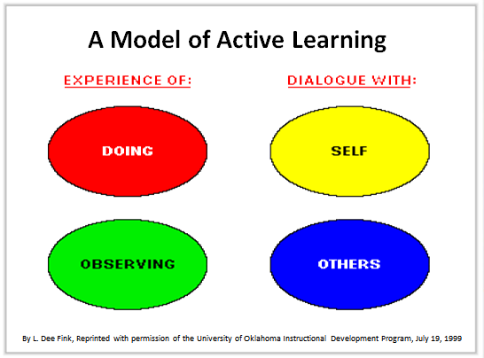
Jantan J. 2010
Look at and consider Fink’s Model of AL (above) – Through Dialogue and Experience we acquire knowledge. It is through dialogue with SELF principally and with others secondarily that APK must happen. The next slide focuses on aspects of the SELF that play key roles in APK in order to make sense of new information.
Time: 3 minutes

Slide 8

William Tweedie’s Model of Prior Knowledge
The following slide visualises the author’s original, extended framework to describe Prior Knowledge.
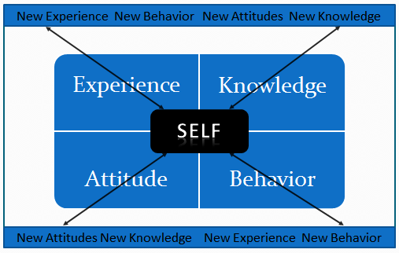
(Tweedie 2012)

Prior knowledge is who we are as thinking beings. It is this SELF, “a composite of who we are, based on what we have learned from both our academic and everyday experiences” (Kujawa and Huske, 1995) that we bring to new learning situations.
Students learn and remember new information best when it is linked to relevant prior knowledge. Teachers who link classroom activities and instruction to prior knowledge build on their students' familiarity with a topic (Beyer, 1991) and enable students to connect the curriculum content to their own culture and experience. (Presseisen 1995)
Neglected in the literature is the relationship between ‘knowledge and experience’ and ‘attitude and behavior’. I postulate that the relationship is a critical one especially in the context of learning a new language where feelings are involved in the process to a greater extent than in any other learning. Language is at the heart of our ‘selves’. It is how we express who we are, our thoughts, desires, beliefs, aspirations and emotions. It is how others recognise who we are. Therefore it is necessary that we create a positive, supporting, safe and comfortable atmosphere for our students. One essential means of doing this is to demonstrate to our students’ our understanding they are unique individuals whose prior knowledge is recognised as unique and valued.
In summary, Experience and Knowledge are directly related to Attitude and Behaviour – in language learning particularly, it is common sense. For the average person, positive, progressive experience and knowledge lead to positive and progressive attitudes and behaviours. To understand and retain new information in what they are reading (the focus of this workshop), students’ need to connect this information to a framework of what they already know and understand, as you will hopefully experience in the activities that follow.
Reading Specialist Dr. Suzanne Clewell explains this idea with a very timely example. (2012 Olympics are underway as I write this.) (Clewell 2012)

Slide 9

Video – Dr. Suzanne Clewell
Transcript of the video:
"Activating prior knowledge is something that we do naturally as adult readers, as mature readers. We always relate what we're reading to something we know. As a matter of fact when we read we really have to think about those connections. Sometimes students don’t access their background knowledge because they never think that it's important or if they don’t have the background knowledge the teacher doesn’t have an opportunity to really build that background knowledge."

"If a student were reading about let's say Zeus and Greece and those first games on Mt. Olympus maybe the Olympics would never come to mind. But if there were a brief discussion in class about what the Olympics were, and most students can recall seeing at least one Olympics, that knowledge would help that student to understand the passage."

"So it's finding out if the students have the background knowledge. Then if they don't being able to expose them to some information that's going to help them to be able to think about those connections with what they're reading."
Dr. Suzanne Clewell – Video excerpt - 1.6 minutes
http://www.thinkport.org/career/strategies/reading/activate.tp

Kujawa, S., & Huske, L. (1995). The Strategic Teaching and Reading Project guidebook (Rev. ed.). Oak Brook, IL: North Central Regional Educational Laboratory.

Activity 4 – APK in EFL Contexts

Students may have the knowledge but not the language ability OR
They may not have the knowledge and therefor, the language ability in L1 must be such as to understand and learn the concepts needed and then learn the L2 equivalent.
If the student knows but can’t explain in English the teacher must be aware of this. L1 is therefore necessary to focus on building lexis and language ability. Many research studies have led to this conclusion. NOTE: However, we must always keep in mind the distinguishing elements among the ESL, ESL Immersion, and EFL contexts.
Feelings/Attitudes (the Affective Filter, as Krashen hypothesized) are absolutely critical in the process of L2 acquisition as discussed previously.
Krashen, Stephen D. Second Language Acquisition and Second Language Learning. Prentice-Hall International, 1988.

Now let’s get to the sampling of strategies and activities we selected for today.

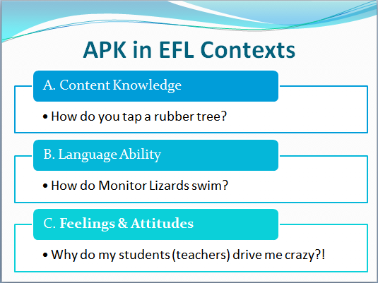

PART 2 – Practice

Activity 5 – Simple Word Poem

Name: _______________________________ Date: _______________________

Word Poem
To create a word poem, use the poem frame below, which asks you to use different parts of speech to describe your topic.

______________________
Topic—a noun

______________________ _____________________ _______________________

adjective adjective adjective

______________________
verb

______________________ ______________________ ______________________
adverb adverb adverb

______________________ ______________________
New adjective New noun

Activity 6 – Question Answer Relationships (QAR)
Good readers pose questions before, during, and after reading. Being aware of HOW to gain information is just as important as the material that is actually gained. Remember—being a good reader involves thinking about how as well as what you read.

What kinds of questions do readers ask themselves when reading?

In the book Questions
A. Right There
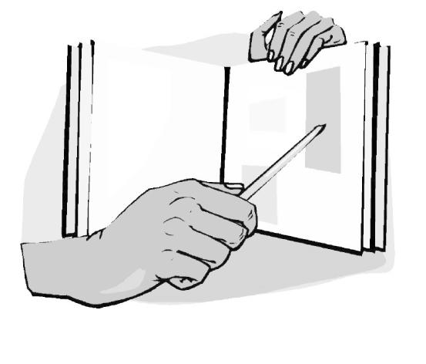
It’s right there! The answer to this question can be found in one place in the text.

B. Think and Search
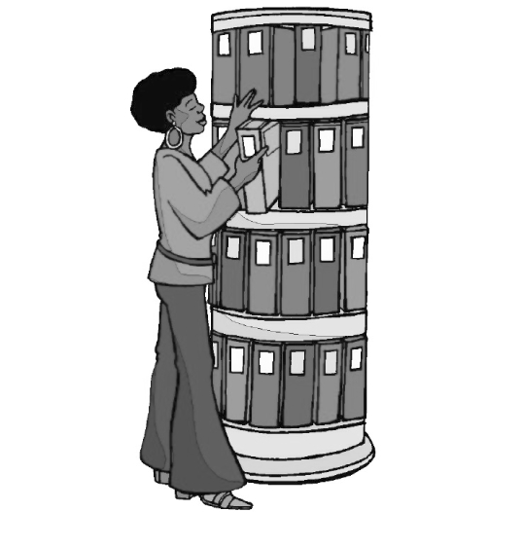
To arrive at the answer to this question, you need to piece together different parts of one or more texts.

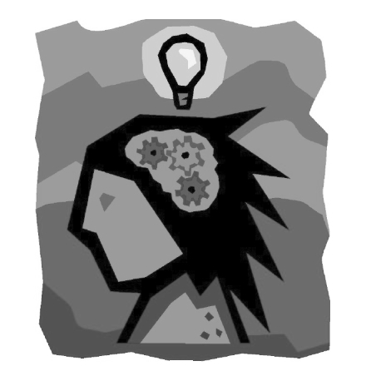
In my head Questions
A. On My Own
This type of question invites you to make a personal connection to something you have experienced or are experiencing.
B. Author and Me
The response to this question asks you to consider the author’s perspective/ position and your own experiences and views to formulate a response.

IRA/NCTE, 2003. ReadWriteThink materials may be reproduced for educational purposes.
Downloaded from: www.readwritethink.org/files/resources/lesson_images/.../qar.pdf

Why teenagers find learning a drag
- 14:09 19 March 2010 by Jessica Hamzelou
- For similar stories, visit the http://www.newscientist.com/topic/teenagers and http://www.newscientist.com/topic/Brain Topic Guides
Being a teenager can be a drag. As if dealing with peer pressure and raging hormones weren't hard enough, your ability to learn new things is also reduced. Now the brain molecules behind this learning deficit have been identified in mice - and blocked.
When children hit puberty, their ability to learn a second language drops, they find it harder to learn their way around a new location and they are worse at detecting errors in cognitive tests.
Why is this? Sheryl Smith and her colleagues at the State University of New York now reckon that all of these behavioural changes could be due to a temporary increase in a chemical receptor that inhibits brain activity in an area responsible for learning.
In 2007, Smith's team discovered that the number of these receptors soared in mice when they hit puberty, before falling back in adulthood. In their latest study, Smith's team set about finding out if these receptor changes in mice might lead to impaired learning abilities, rather like those seen in pubescent humans.
Shocking memory
The group examined the hippocampus – a region known to be involved in learning – in mouse brains. Sure enough, pubertal mice had seven times as many of the receptors as infant mice. In adulthood, the number of these receptors fell back to an intermediate level.
The team was also able to examine individual neurons and could see that the extra receptors were being expressed specifically at "neural projections" – sites within the hippocampus known to be involved in learning. This was further evidence that the increase in receptors might affect learning.
Finally, the group measured spatial learning abilities in the mice. The creatures were placed on a rotating platform, on which a stationary section delivered a mild electric shock. After a single shock, the infant mice learned to dodge the danger zone. The pubertal mice, however, failed to learn to avoid it even after several rounds.
Smith reckons that the same mechanism might underlie the learning deficits teenagers experience. Cheryl Sisk at Michigan State University at East Lansing agrees that "mouse puberty is similar to human puberty, although the timescale is different".
Learning restored
"The research adds to the growing body of literature indicating that puberty and adolescence are a unique period of nervous system development," says Sisk. "Adolescents aren't just in between children and adults. Their behaviour is different from both."
In a further experiment, Smith found that she could remove the learning deficit by injecting pubertal mice with THP – a stress steroid. In children and adult humans, THP is naturally released in response to stress. It reduces brain activity and calms you down, says Smith. But in pubertal mice, THP has the opposite effect – increasing their stress.
Smith suggests that in her most recent experiment, giving extra THP to pubertal mice similarly increased their brain activity and that this activity may have compensated for their learning deficits.
If similar mechanisms underlie teenage learning deficits in humans, this result might point to ways to deal with them - either through behavioural changes or drugs.
Smith suggests that a synthetic form of THP could be developed for teenagers with learning difficulties, although she acknowledges that care would need to be taken not to create any new problems. "We would have to be careful not to affect their mood," she says.
Sisk cautions that it's too soon to apply the results to humans or to other types of learning outside the spatial type tested in the mice.
Participants may use the QAR Rubric on the following page to gauge their success with this strategy.
Journal reference: Science, DOI: 10.1126/science.1184245 www.newscientist.com

Student Name ________________________

QAR RUBRIC

The student accurately identifies each of the four question types (1 point each)

Right There ______
Think and Search ______
On My Own ______
Author and Me ______

The student's responses demonstrate a close, careful reading. ______
(4 points)
The student makes appropriate links to the text for in the book questions. ______
(4 points)
The student makes appropriate connections for in my head questions. ______
(4 points)
The student demonstrates reflective reading habits during group conversation. ______
(4 points)

TOTAL (maximum of 20) ______

Copyright 2003 IRA/NCTE. All rights reserved.
ReadWriteThink materials may be reproduced for educational purposes.

Activity 7 - Diamante Poem

Name: _________________________________ Date: _______________________

Diamante Poem
To create a diamante poem, use the poem frame below, which asks you to use different parts of speech to describe your topic.
______________________
Topic—a noun

______________________ ______________________
adjective adjective

______________________ ______________________ ______________________
verb verb verb

____________________________________________________________________
Four-word phrase

______________________ ______________________ ______________________
Verb verb verb

______________________ ______________________
Adjective adjective

______________________
renaming noun

Activity 8 – Compare and Contrast/Similarities and Differences
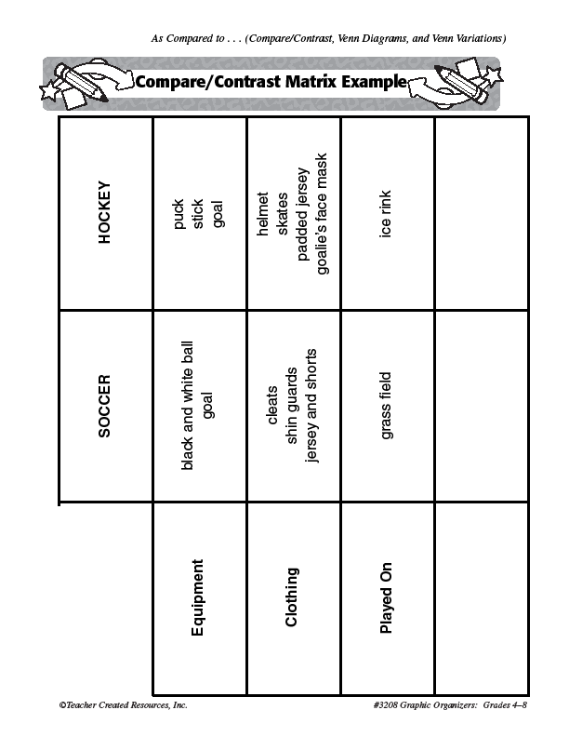
Example

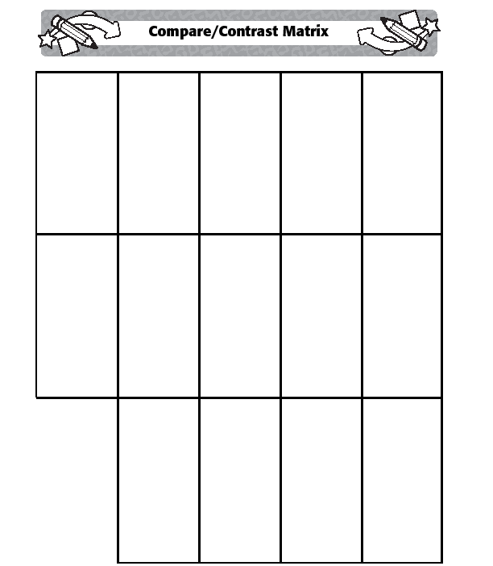
Form

Activity 9 – Read Aloud

The City Mouse and the Country Mouse

There once was a mouse who liked his country house until his cousin came for a visit.
"In the city where I live," his cousin said, "we dine on cheese and fish and bread. Each night my dinner is brought to me. I eat whatever I choose. While you, country cousin, work your paws to the bone for humble crumbs in this humble home. I'm used to finery. To each his own, I see!"
Upon hearing this, the country mouse looked again at his plain brown house. Suddenly he wasn't satisfied anymore. "Why should I hunt and scrape for food to store?" he said. "Cousin, I'm coming to the city with you!"
Off they went into the fine town house of the plump and prosperous city mouse.
"Shhh! The people are in the parlor," the city mouse said. "Let's sneak into the kitchen for some cheese and bread."
The city mouse gave his wide-eyed country cousin a grand tour of the leftover food on the table. "It's the easy life," the city mouse said, and he smiled as he bit into a piece of bread.
Just as they were both about to bite into a chunk of cheddar cheese, in came the CAT!
"Run! Run!" said the city mouse. "The cat's in the house!"
Just as the country mouse scampered for his life out of the window, he said, "Cousin, I'm going back to the country! You never told me that a CAT lives here! Thank you, but I'll take my humble crumbs in comfort over all of your finery with fear!"

Heather Forest - Story Arts http://www.storyarts.org

Activity 10 – Shape Poems

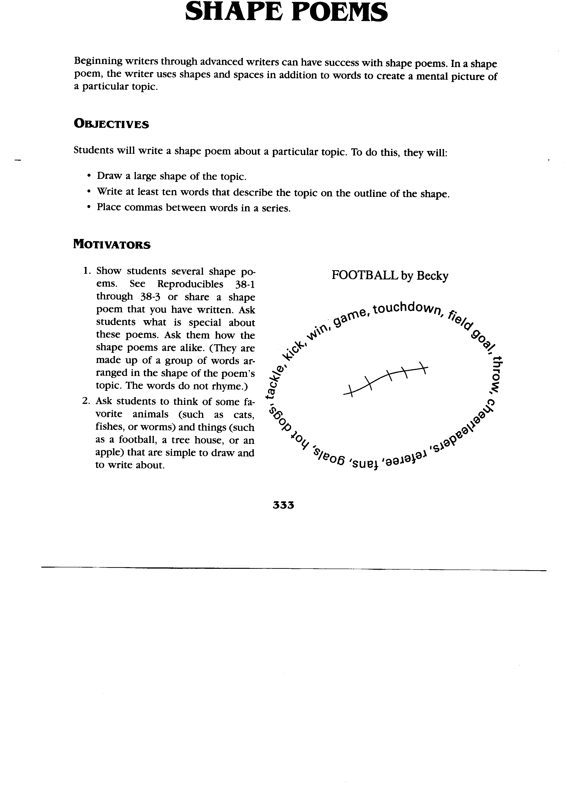

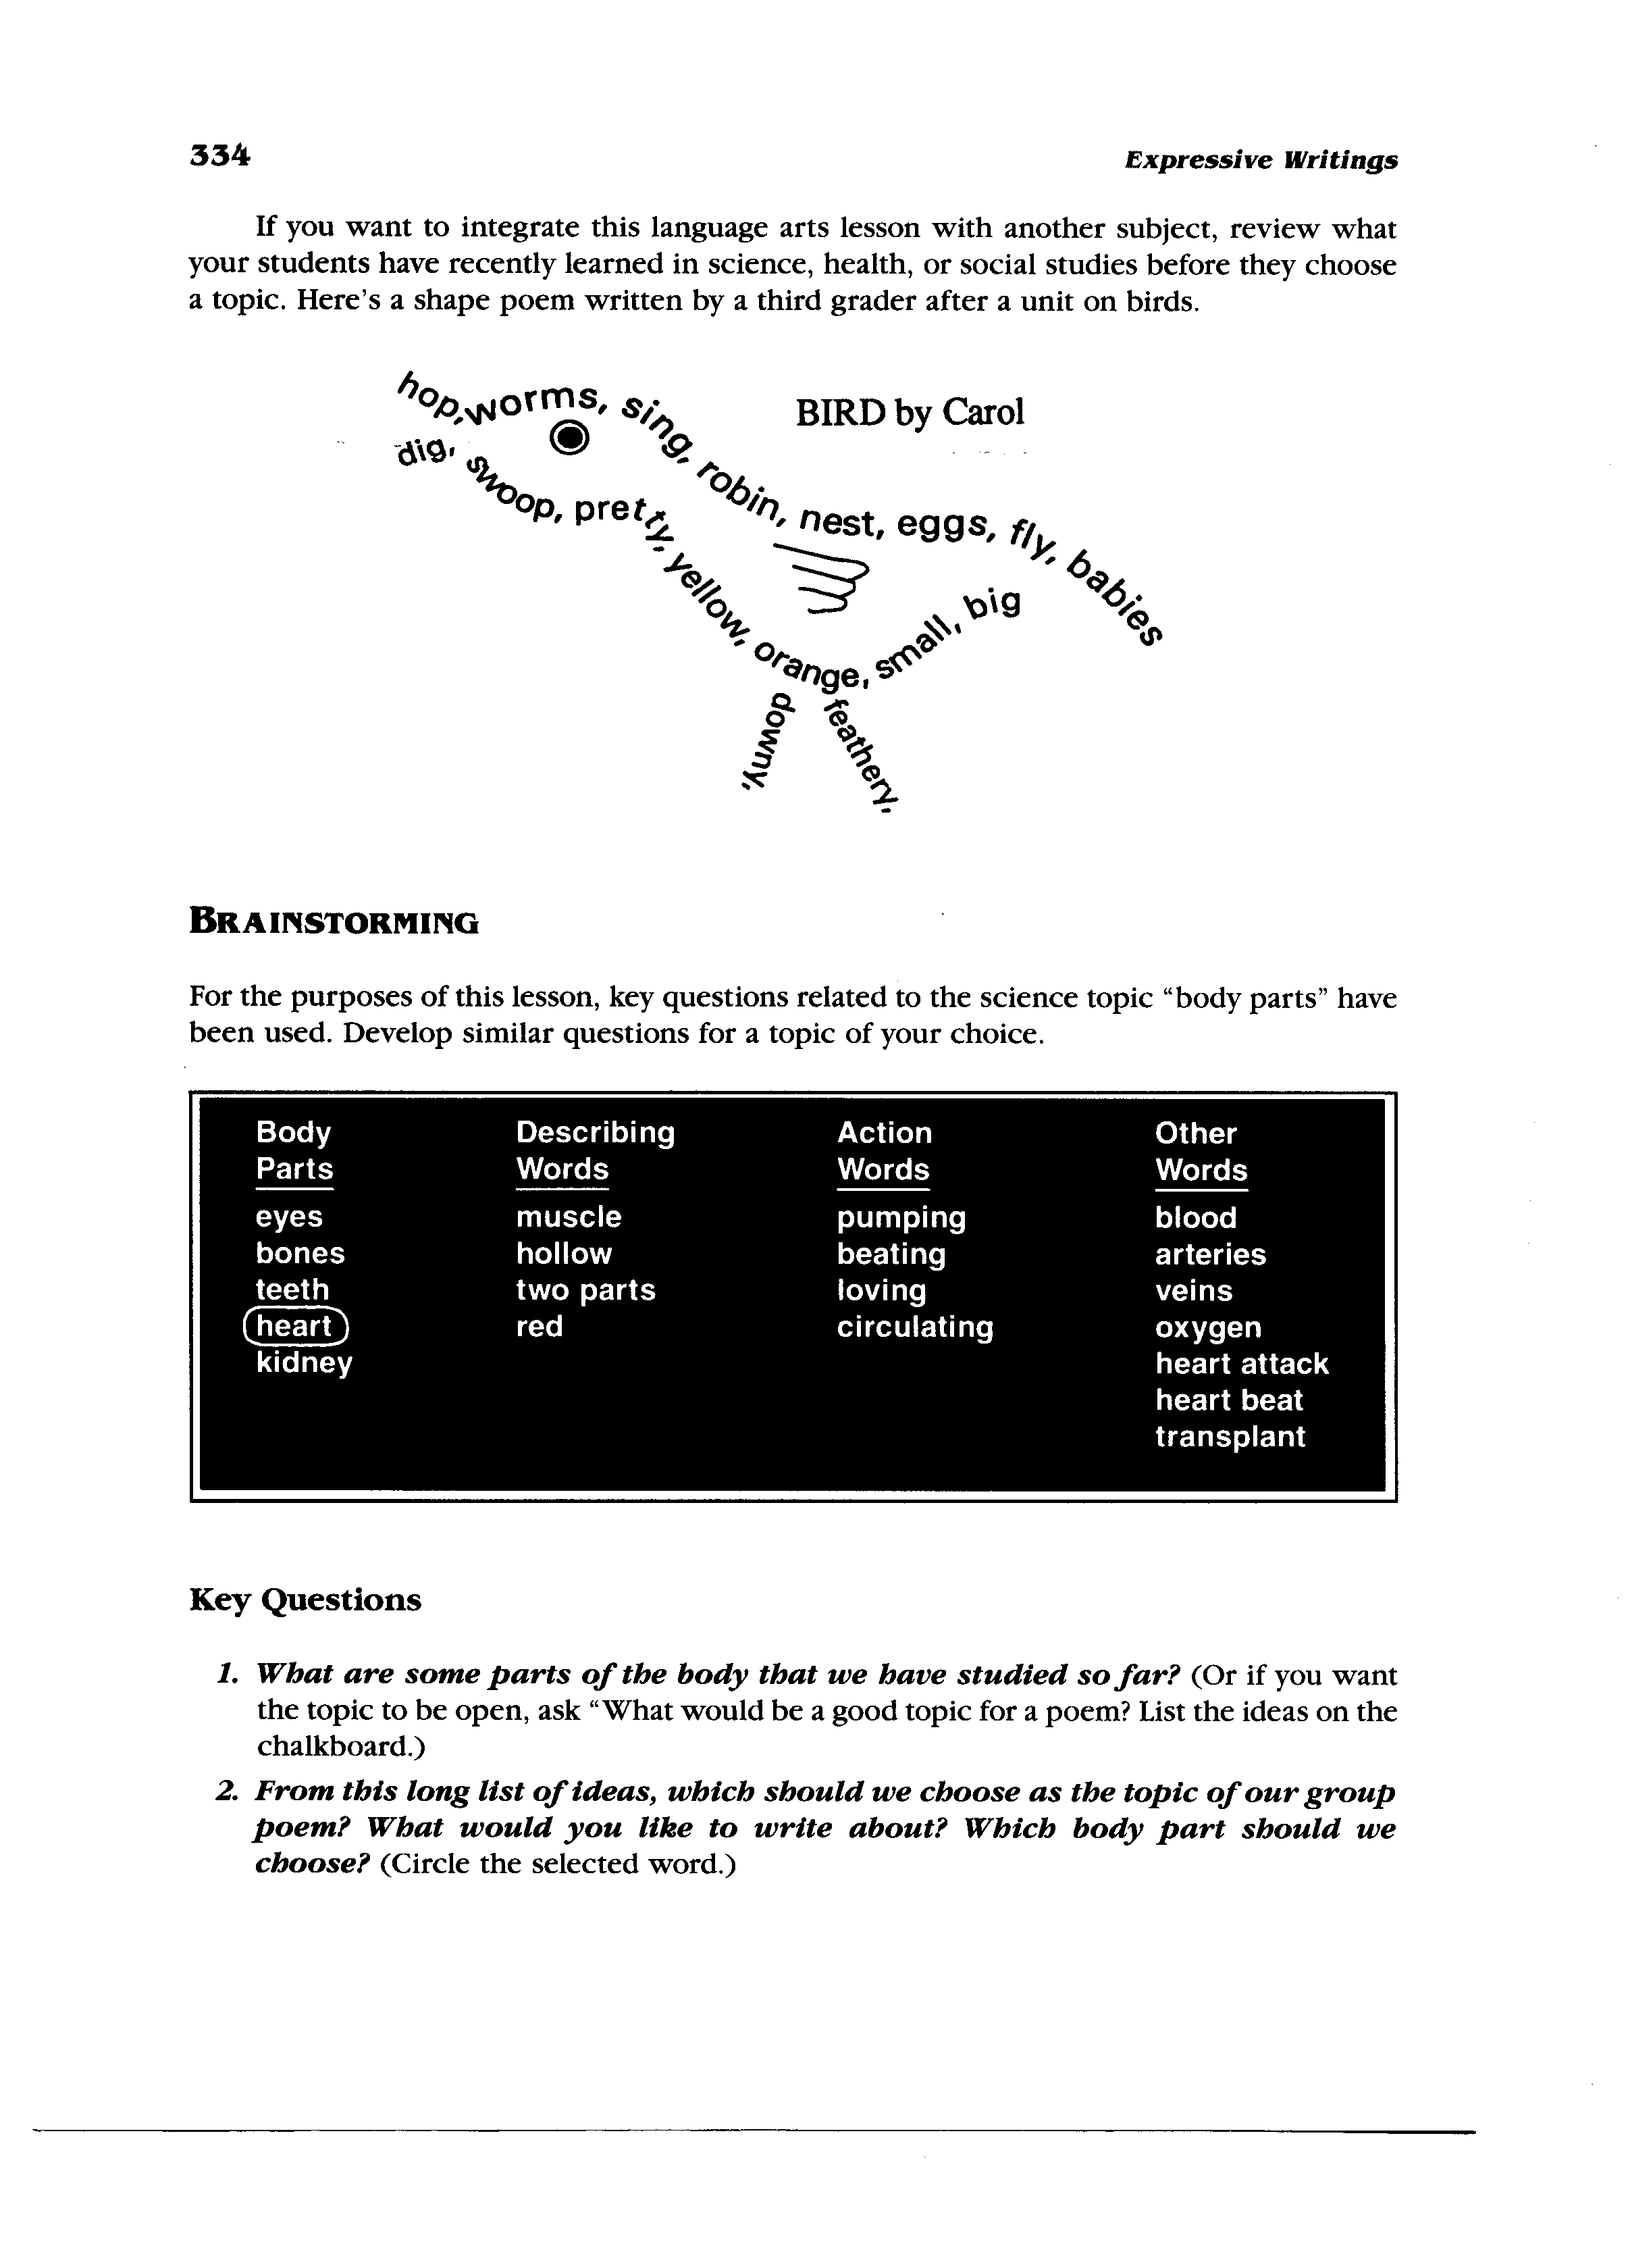
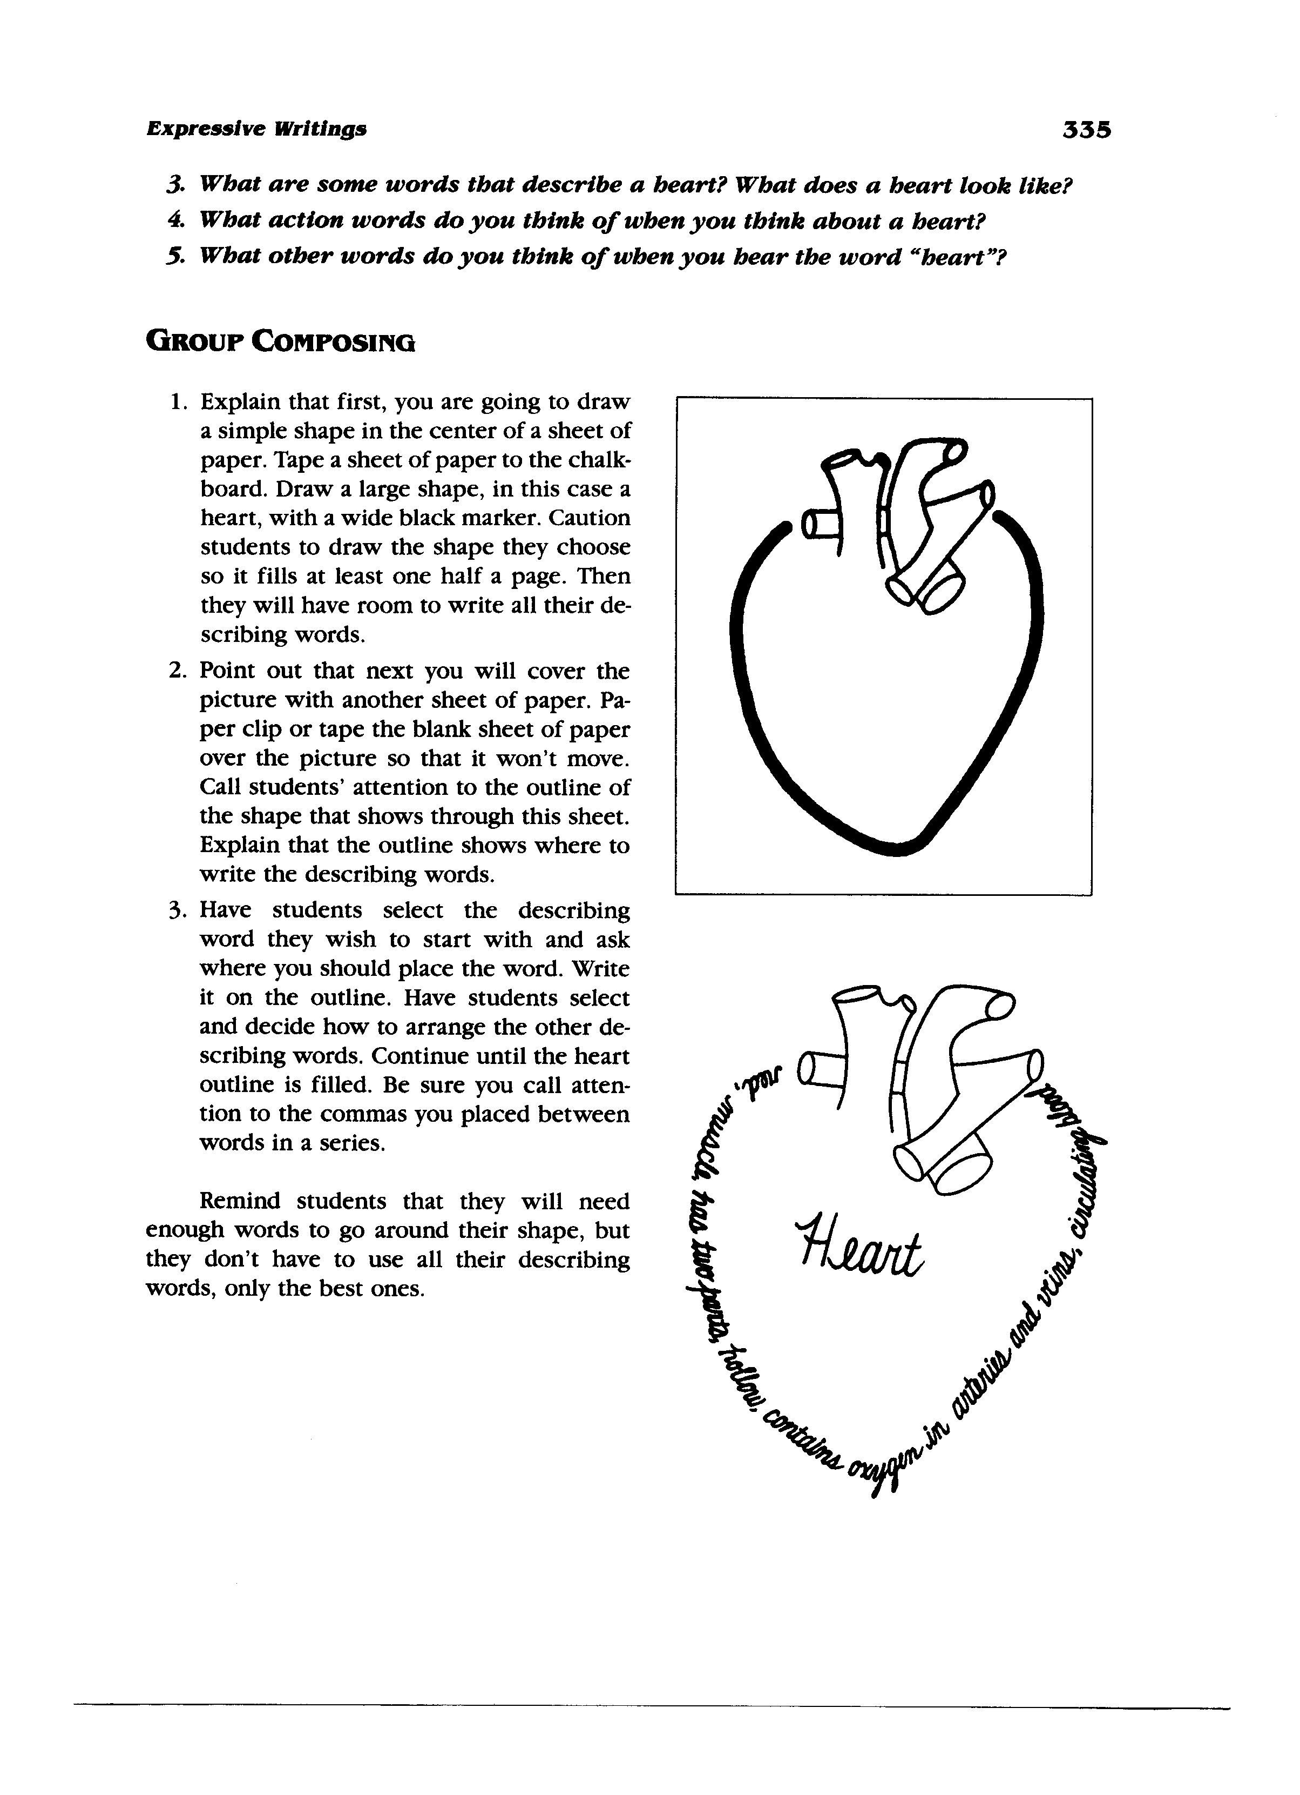
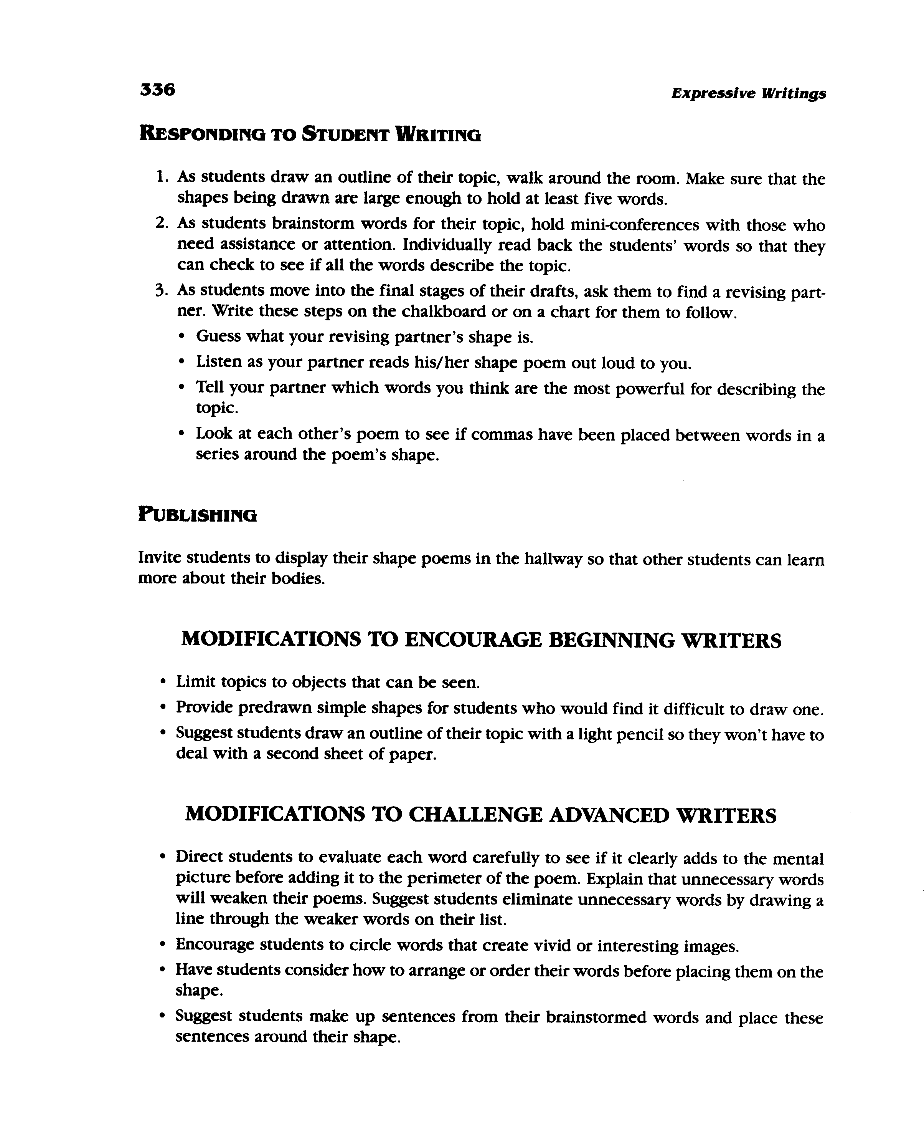
Sunflower, S. 2006 Really Writing, San Francisco: Jossey Bass A Wiley Imprint downloaded from: http://www.teachervision.fen.com/poetry/printable/5418.html?

Each member of your group chooses a different word from the following categories assigned by the facilitator to create a shape poem:

Group 1 Group 2 Group 3 Group 4 Group 5
- Frog bear bananas flower pond
- Hornbill rabbit milk pear armadillo
- Monkey cow carrot egg leaf
- Lizard snake cheese bean root
- Mouse cat rice potato raindrop

Activity 11 – Elements of Thieves - A Strategy for Previewing Textbooks

THIEVES:
This activity will help students with comprehension by allowing them to preview the text structure in an organized manner. This pre-reading strategy will allow students to “steal” information before they actually begin reading the chapter. Students will survey the text in the following manner:

Title – Students sometimes skip the title, but it provides valuable information by establishing the topic and the context of the chapter. If the text is written in chronological order, the title may indicate where the chapter would fit on a timeline. Some questions that the student may ask while looking at the title include:
- What do I already know about this topic?
- How does it connect to the previous chapter?
- How can I turn this title into a question to focus my reading?

Headings – Headings indicate the important sections of the chapter. They help students identify the specific topics covered. Students can turn the headings into questions to create a more focused look at information covered in the chapter. Some questions that the student may ask while looking at the headings include:
- How does this heading let me know what I will be reading about?
- What topic will be discussed in the paragraphs below this heading?
- How can I turn this heading into a question that can be answered when I read this section?

Introduction – The introduction provides an overview of the chapter. It may come after the title and before the first heading. Sometimes the goals and objectives of the chapter are stated in the introduction. Some questions that students may ask when previewing the introduction include:
- Is the introduction marked or do I have to locate it?
- Does the first paragraph introduce the chapter?
- What important information will I find in the introduction?
- Do I already know anything about this?

Every first sentence in a paragraph – First sentences are often the topic sentences of the paragraph, and by reading these a student can get an idea of the information that will be contained in the chapter.

Visuals and Vocabulary – Students should look at all pictures, charts, tables, maps and graphs contained in the chapter. They need to read the captions and labels on each. This enables students to learn a little about the topic before they begin to read. Some questions that students may ask about the visuals include:
- How do these visuals relate to the content of this chapter?
- What can I learn from them?
- How do the captions help me understand the visual?
Vocabulary unlocks the meaning of the content. Students need to understand vocabulary in order to comprehend the text. Vocabulary may or may not be identified as key words. It might be highlighted or italicized in the text. Some questions that students may ask about the vocabulary include:
- Is there a list of key words and are they defined in the glossary?
- Are there important words in boldface or italics?
- Do I know the important words?
- Are there other words I don’t know?

End-of-Chapter Questions – These questions indicate important points and concepts from the chapter. Just reading these questions will help students target information that is important in the text and establish a purpose for reading. Some questions that students may ask about the end-of-chapter questions include:
- What do these questions ask?
- What information will be important in this chapter?
- How do I locate this information in the text?

Summary – Many texts contain a summary at the end of the chapter. Students can read the summary to activate prior knowledge and give them an idea of the important concepts contained in the chapter.
THIEVES was created by Suzanne Liff Manz, an educational therapist and instructor at Nassau Community College in Garden City, NY. It was published in The Reading Teacher Volume 55 Number 5 in February, 2002.

An example of the pages to be distributed to you separately follows.

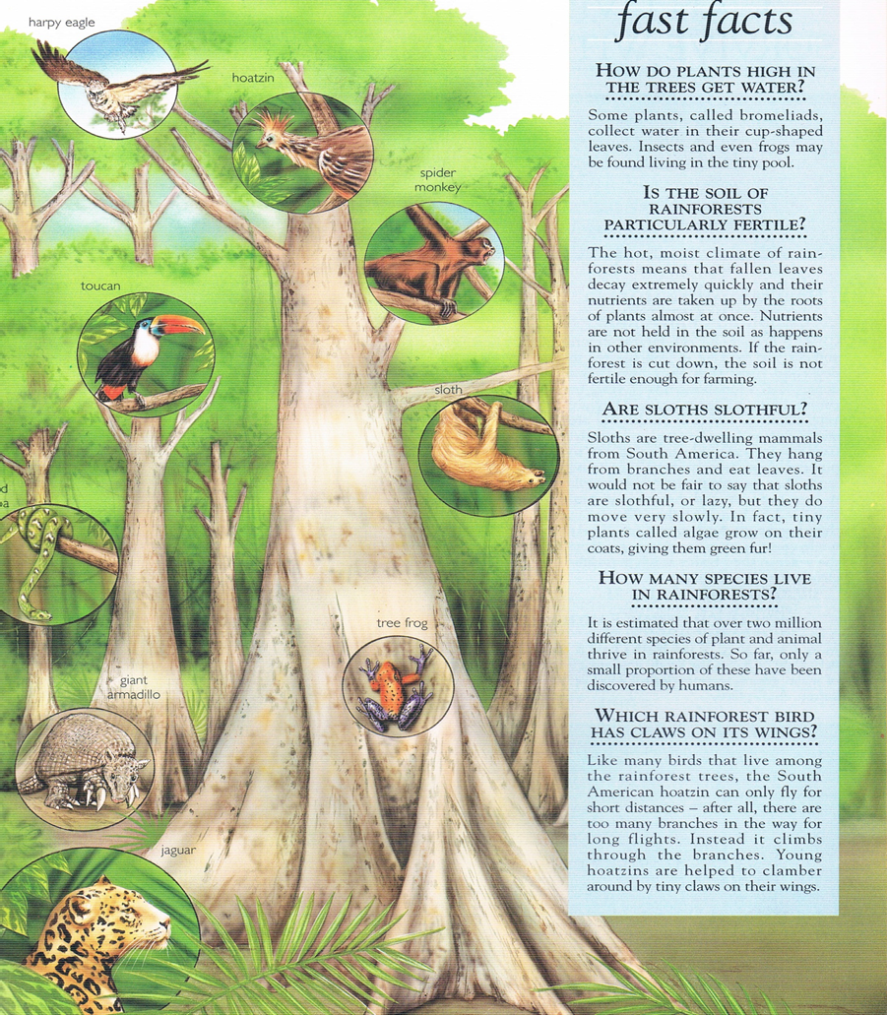

Activity 12 – Building Vocabulary Cloze Reading

You Are Beautiful As You Are - Cloze

There was once a crow who did not like his feathers.
"I wish I were a ______________!" he would say.
"You are _____________ as you are!" the other crows insisted.
"How plain and dull you seem to me!" he'd complain, and fly off to _________ peacocks.
The peacocks __________ __________ with their _____________l tail feathers outstretched. To the delight of the crow, some of the peacock feathers lay on the ground when the peacocks left.
Crow _________ _________ to the ground and ___________ the feathers into his ____________ ____ ________. He ______________ a few sticking up from his head.
"Now I am as beautiful as a peacock," he said.
But, when he went to join them in their strutting, the peacocks _________ him and pecked him. What a fuss!
"You are not a peacock," they said, "Don't ___________ us!"
Bruised and still ____________ some broken peacock feathers in his tail, he returned home.
After all his ___________, no one wanted his ____________!
As he sat ____________, the other crows said, "It's foolish to try and be what you're not. Learn to _______ the feathers you've got!"

1. strutted about 2. admire 3. flew down 4. beautiful 5 stuck. 6. insults
7. company 8. love 9. peacock 10. colorful 11. attached 12. poked
13. imitate 14. pecked 15. alone 16. dull 17. feathers 18. wings and tail
19. dragging 20. foolish
If you can’t fill in a blank with a word here, make up a work that fits!

You Are Beautiful As You Are – Complete text
There was once a crow who did not like his feathers.
"I wish I were a peacock!" he would say.

You Are Beautiful As You Are - Complete
"You are beautiful as you are!" the other crows insisted.
"How plain and dull you seem to me!" he'd complain, and fly off to admire peacocks.
The peacocks strutted about with their colorful tail feathers outstretched. To the delight of the crow, some of the peacock feathers lay on the ground when the peacocks left.
Crow flew down to the ground and stuck the feathers into his wings and tail. He attached a few sticking up from his head.
"Now I am as beautiful as a peacock," he said.
But, when he went to join them in their strutting, the peacocks poked him and pecked him. What a fuss!
"You are not a peacock," they said, "Don't imitate us!"
Bruised and still dragging some broken peacock feathers in his tail, he returned home.
After all his insults, no one wanted his company!
As he sat alone, the other crows said, "It's foolish to try and be what you're not. Learn to love the feathers you've got!"

Activity 13 – Predicting

The Lion and the Mouse

Part 1
A small mouse crept up to a sleeping lion. The mouse admired the lion's ears, his long whiskers and his great mane.
"Since he's sleeping," thought the mouse, "he'll never suspect I'm here!"
With that, the little mouse climbed up onto the lion's tail, ran across its back, slid down its leg and jumped off of its paw. The lion awoke and quickly caught the mouse between its claws.

Continue writing the story as YOU imagine it here:

___________________________________________________________________
Part 2
"Please," said the mouse, "Let me go and I'll come back and help you someday."
The lion laughed, "You are so small! How could ever help me?"
The next day, two hunters came to the jungle. They went to the lion's lair. They set a huge rope snare.
When the lion came home that night, he stepped into the trap.

Now based on what YOU PREDICTED or on the above continue writing the story here:

___________________________________________________________________
Part 3
He roared! He wept! But he couldn't pull himself free.
The mouse heard the lion's pitiful roar and came back to help him.
The mouse eyed the trap and noticed the one thick rope that held it together. She began nibbling and nibbling until the rope broke. The lion was able to shake off the other ropes that held him tight. He stood up free again!
The lion turned to the mouse and said, "Dear friend, I was foolish to ridicule you for being small. You helped me by saving my life after all!"

The End
Compare your predictions with the true story. Which do you like the best? Why?
Heather Forest - Story Arts http://www.storyarts.org

Thank you for your active participation in today’s workshop on Activating Prior Knowledge. I hope you found it valuable and fun.

Please contact William Tweedie at william.tweedie@yahoo.ca if you would like ideas or additional resources.

References

Baxter, N 1997 1000 Questions and Answers Leicester Bookmart Limited
Clewell S. 2012 Activating Prior Knowledge – Video excerpt – downloaded March 2012 from http://www.thinkport.org/career/strategies/reading/activate.tp
Fink L. D. 1999 Active Learning Oklahoma University of Oklahoma Instructional Development Program
Jantan J. 2010 Student-Centered Learning Active Learning and Compilation of Best Teaching Practices Shah Alam Universiti Teknologi MARA
Forest H. Aesop’s ABC Ancient Fables Retold purchased and downloaded from http://www.storyarts.org
Hamzelou J. 2010 “Why Teenagers Find Learning a Drag.” extracted from: http://www.newscientist.com/topic/Brain Topic Guides Journal reference: Science, DOI: 10.1126/science.1184245 www.newscientist.com
Krashen, Stephen D. Second Language Acquisition and Second Language Learning. Prentice-Hall International, 1988.
Paulson D. R. and Faust .J L. Active Learning For The College Classroom Paulson & Faust, California State University, Los Angeles, Extracted from: http://www.calstatela.edu/dept/chem/chem2/Active/index.htm
Presseisen, B. Z. 1991. Thinking skills: Meanings and models revisited. In A.L. Costa (Ed.), Developing minds: A resource book for teaching thinking (rev. ed). Alexandria, VA: Association for Supervision and Curriculum Development.
Sunflower, S. 2006 Really Writing, San Francisco: Jossey Bass A Wiley Imprint downloaded from: http://www.teachervision.fen.com/poetry/printable/5418.html?
Tweedie W. M. 2012 A Model of Activating Prior Knowledge for Facilitators of Learning Kuala Terengganu IPGKDRI unpublished
Tweedie W. M. 2003 The PRIME Approach to Facilitating English as a Foreign Language Acquisition MA Thesis unpublished. Summary online at http://prime-learning.weebly.com

