21st century teaching tips for teachers
12:11 PM 21st century teaching skills 3 comments Med
To teach is to learn twice over. Learning becomes a life long process and teachers are forever learners. If you ever think you have reached the acme of your performance then you have to know it is the start of your end. Some teachers get lazy after a few years of teaching and others do not go beyond their text book. do you belong to any of these categories ? if so then you are not a teacher but just a hard working student.

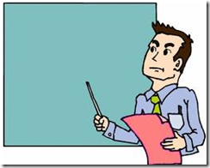

“We cannot hold a torch to light another's path without brightening our own.” We as teachers are entrusted with the heaviest responsibility in the society it is that of the upbringing of educated generations. As Marcus Tullius Cicero said” What nobler employment, or more valuable to the state, than that of the man who instructs the rising generation “. Aristotle has even gone far to honor teachers over parents when he said “ Those who educate children well are more to be honored than parents, for these only gave life, those the art of living well “. We should do our best to live up to what our society expects from us. We need to be full of aspiration, hope and enthusiasm to be able to unsettle our students minds , flame their intellect and widen their horizons. for education is not the “filling of a pail but the lighting of a fire”.

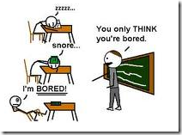

Change and accustomization should always be among our fundamental traits. As methodologies and approaches change so do our teaching styles and habits. The way our teachers taught us could definitely not be the way we teach our students now and as John Dewy once said “ If we teach today’s students as we taught yesterday’s, we rob them of tomorrow.” We need to swim with the current and not against it and adopt the latest trends in education and be able to integrate technology into our teaching . We are innovators and aspirers after all.
After this short introduction , i am going to present to you some well- designed ideas about how we can be better teachers in our century. I know the list is not exhaustive but should serve as a springboard to a comprehensive search from your part.
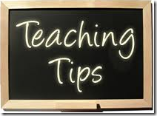

1 - Be ready to accept differences and know that students are not all alike and allow each student the opportunity to shine
2 - Use different strategies in different situations . Instruction may be differentiated in content, process, or product according to the students’ readiness, interests, or learning style.
3 - Use multiple instructional strategies and a variety of representations at the same time to increase the chances of reaching all students.
4 - Acknowledge that students have different learning styles, learn at different speeds, are at different comfort levels of thinking abstractly, and differ in abilities to make connections.
5 - Make sure you integrate a varied set of activities such as skill practice, problem solving, manipulatives, games, working with technology such as computers or calculators, graphs and other visuals,
6 - Never separate assessment from instruction and make sure to focus on qualitative assessment more than quantitative assessment.
7- Use a variety of formal tests, homework assignments, journals, discussions, and presentations.use the results of assessments to continuously plan lessons on skills that are not yet mastered by your students.
8 - Never assume what students might or might not know but find out ! use pre- assessment as a first step
9 - Get to know your students; know their interests and socialize with them within the limits allowed. students will be more engaged in the learning if they feel it was developed around their interests.
10 - From time time you need to stop and reflect about your lessons , students and the way you teach. try modifications and see what works and what does not.
11- You need to realize that teaching is evolutionary and always evolving. It is a bottomless well.
12 - Hold students accountable for their own learning and let them fgeel a sense of responsibility towards what they are learning through the effective use of heterogeneous group activities.
13 - Teachers should be characterized by certain holistic and student centered features , some of them are summarized below . Gratitude and thanks goes back to Andrew Churches who has provided this diagram .

